Friday, May 5, 2017

North American Occupational Safety and Health (NAOSH) Week
Sunday, May 7th, to Saturday, May 13th, 2017

Make Safety a Habit!

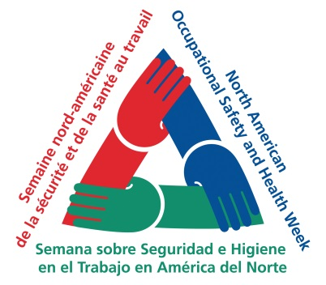

What is NAOSH Week?
North American Occupational Safety and Health (NAOSH) Week is an international initiative focused on highlighting the importance of health and safety in all aspects of our lives. Beginning in 1997, NAOSH Week events and activities have been held in Canada, the United States and Mexico with the goal of focusing the attention of all individuals on injury and illness prevention in the workplace, at home and in the community.
The NAOSH Week logo, three hands forming an equilateral triangle, represents cooperation and commitment among the many partners in health and safety. In Canada, NAOSH Week is led by the Canadian Society of Safety Engineering (CSSE), who, work in partnership with many organizations to promote NAOSH Week events. NAOSH Week activities are coordinated across the country by committees, comprised mainly of volunteers, dedicated to raising awareness and reducing injuries and illnesses in our workplaces and communities.
Celebrating NAOSH Week at Humber.
Watch for our daily Communique announcements during NAOSH week starting, Monday, May8 ^{the}, 2016 to Friday, May 12th, 2017, where each day we will provide information on a common workplace hazard.
The announcement on Friday May 12th will include a chance to win some great prizes!
Monday’s topic: Reporting Workplace Injuries.

HR Services | Health and Safety Services

NAOSH Week is led by the Canadian Society of Safety Engineering (CSSE).
More information about NAOSH Week can be found at www.naosh.ca or www.csse.org.

