Update: Road closure for wet utilities installation. Humber College Boulevard and Highway 27.
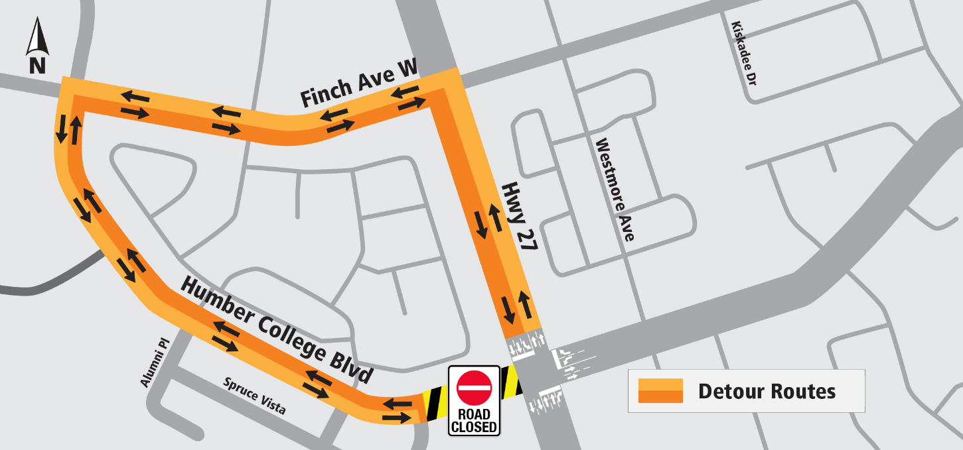
Septemeber 16-17,2022

LOCATION  - Humber College Boulevard and Highway 27. |  | IMPACT  - Humber college boulevard will be closed for two consecutive nights from Arboretum to HWY27.  - Minor field modifications may occur when needed to complete work safely and minimize impact on the public.
TIMING  - September 16-17, 2022  - Work hours from 7 p.m. to 6:00 a.m. |  | WORK DESCRIPTION  - Wet utilities installation.

DETAILED DESCRIPTION:

As part of the Finch West Light Rail Transit (LRT) Project, crews will be working on the wet utilities installation at the intersection of Humber College Boulevard and Highway 27. The work will be done overnight only and is scheduled for September 16 and September 17, 2022, approximately.

Sidewalks and crosswalks may be closed periodically. Minor field modifications will occur when needed to complete work safely and minimize impact on the public.

There will be a Paid Duty Officer, flaggers, and detour signs to direct traffic, as needed.

We will continue monitoring noise and vibration levels during these activities to identify the need for mitigative actions.

WORK HOURS:
- Work will primarily occur on Friday and Saturday from 7 pm to 6 am.
- Signs are installed to keep local residents informed about the closure.
- Dates are tentative and may change. Please visit us at www.metrolinx.com/finchwestlrt for up-to-date information.
- Inclement weather or unforeseen circumstances may delay work activities.

WHAT TO EXPECT:
- Heavy trucks and equipment in the area.
- Due to the nature of the work, at times there will be dust, noise and vibration associated with this work.
- Nearby businesses and residents can expect noise from excavators, bobcats, vacuum trucks and other construction equipment caused by road work activities.
- Expect delays near work zones.

PEDESTRIAN, TPAFFIC AND TRANSIT DETAILS:

- Road and sidewalk restrictions are in place within the construction area to protect workers and the public.
- Pedestrians will be re-routed around the construction area when possible. For safety reasons, pedestrians may be diverted to the sidewalk on the opposite side.
- In the event of any parking restrictions, advanced notice will be provided.
- A minimum of one lane of traffic in each direction along Finch Ave. W. will be maintained at all times.

