

**How Do I Access Chrome River?**

1. Go to [myexpenses.humber.ca](http://myexpenses.humber.ca)
2. Login with your Humber credentials

You should be presented with a *Humber College Sign in page*. Employees directed to a *Chrome River Login page* DO NOT have access to Chrome River.

Employee **HAS** Chrome River Access

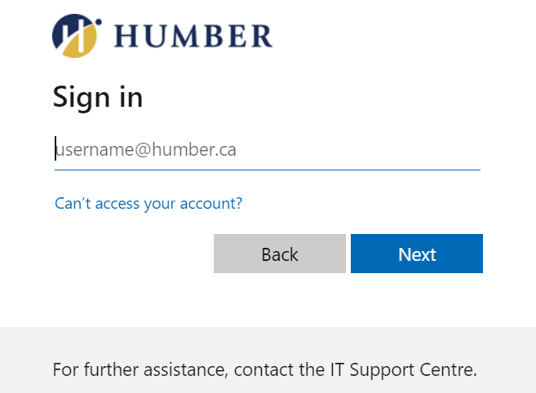

Employee **DOES NOT** have Chrome River Access

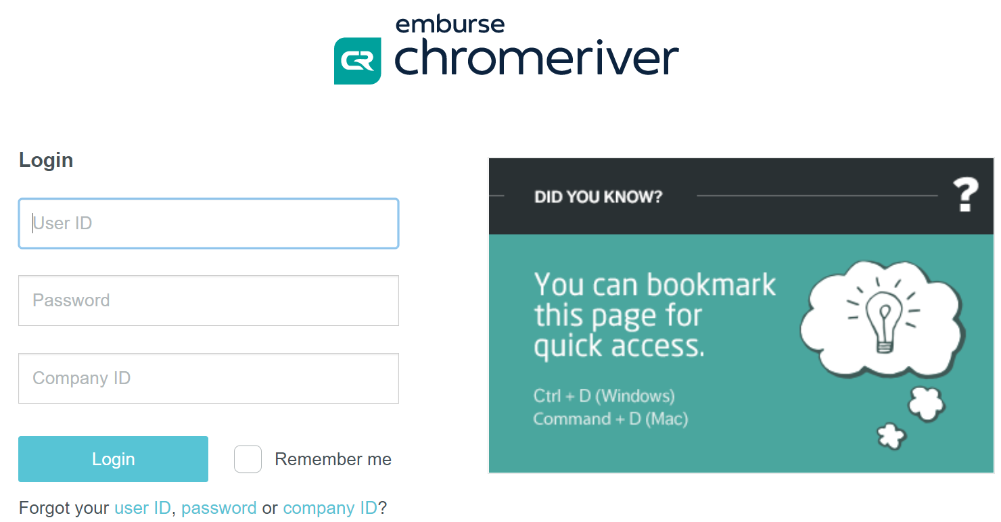

Please ask your Business Admin to submit a **Grant or Revoke Finance Security** eForm if you do not have Chrome River access and need to submit a reimbursement request.

**Chrome River Training**

Training will be offered during the week of **March 21-25**. Each session will be offered twice – **please only register once per session**. Instructions on how to access the sessions will be provided within the ***Eventbrite Order Confirmation* email**.

1. **Submitting PCard Transactions & Out-of-Pocket Claims via Chrome River (1hour)**

This session will cover basic Chrome River navigation (including access and login), learning how to reconcile transactions (PCard & Out-of-Pocket), understanding expense report statuses and transactions requiring special approvals.

* [Tuesday, March 22 - 10:30-11:30am](https://www.eventbrite.ca/e/training-submitting-pcard-transactions-out-of-pocket-claims-via-chrome-tickets-291522139567)
* [Thursday, March 24 - 2:00-3:00pm](https://www.eventbrite.ca/e/training-submitting-pcard-transactions-out-of-pocket-claims-via-chrome-tickets-291532580797)

1. **Submitting Travel & Expense Reimbursement Requests via Chrome River (1 hour)**

This session will cover basic Chrome River navigation (including access and login), learning how to submit Out-of-Pocket expenses, understanding expense report statuses and transactions requiring special approvals.

* [Monday, March 21 - 9:30–10:30am](https://www.eventbrite.ca/e/submitting-travel-expense-reimbursement-requests-via-chrome-river-tickets-291539501497)
* [Wednesday, March 23 – 2:30-3:30pm](https://www.eventbrite.ca/e/submitting-travel-expense-reimbursement-requests-via-chrome-river-tickets-291543914697)

As of **February 28, 2022**, employee PDF requests for out-of-pocket reimbursement are NOT being accepted. ALL employee reimbursement requests must be electronically submitted via Chrome River.

**Chrome River Training for Pcard and Employee**

**Out-of-Pocket Business Expense Reimbursements**

**March 21 - 25**



If anyone has any questions, please contact:

Kelly Tsoumagas

Director, Financial Services

[Kelly.Tsoumagas@humber.ca](mailto:Kelly.Tsoumagas@humber.ca)

Paula Borges

Manager, Financial Systems, Technology & Training

[Paula.Borges@humber.ca](mailto:Paula.Borges@humber.ca)

Staci Lindsay

Manager, Accounts Payable

[Staci.Lindsay@humber.ca](mailto:Staci.Lindsay@humber.ca)

**3. Chrome River Approver - Role and Responsibilities (30min)**

This session will cover basic Chrome River navigation (including access and login), explain the role and responsibilities of Approvers, how to approve expense reports (PCard and Out-of-Pocket expenses), and how to set-up a Delegate.

* [Monday, March 21 - 3:00-3:30pm](https://www.eventbrite.ca/e/chrome-river-approver-role-and-responsibilities-tickets-291546482377)
* [Thursday, March 24 - 11:00-11:30am](https://www.eventbrite.ca/e/chrome-river-approver-role-and-responsibilities-tickets-291549080147)

**4. Chrome River Delegates - Role and Responsibilities (30min)**

This session will cover basic Chrome River navigation (including access and login), explain the role and responsibilities of Approvers, how to approve expense reports (PCard and Out-of-Pocket expenses), and how to set-up a Delegate.

* [Tuesday, March 22 – 2:00-2:30pm](https://www.eventbrite.ca/e/chrome-river-delegates-role-and-responsibilities-tickets-291550203507)
* [Friday, March 25 – 10:30-11:00am](https://www.eventbrite.ca/e/chrome-river-delegates-role-and-responsibilities-tickets-291551035997)

**5. Sending/Uploading Expense Receipts to Chrome River (30min)**

This session will cover uploading receipts to Chrome River using your Chrome River account or Chrome River SNAP app

* [Wednesday, March 23 – 10:00-10:30am](https://www.eventbrite.ca/e/sendinguploading-expense-receipts-to-chrome-river-tickets-291555990817)
* [Friday, March 25 – 2:00-2:30pm](https://www.eventbrite.ca/e/sendinguploading-expense-receipts-to-chrome-river-tickets-291556562527)