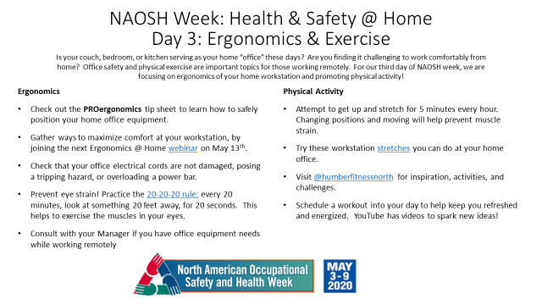

Communique:

North American Occupational Safety and Health Week (NAOSH)
Is your couch, bedroom, or kitchen serving as your home “office” these days? Are you finding it challenging to work comfortably from home? Office safety and physical exercise are important topics for those working remotely. For our third day of NAOSH week, we are focusing on ergonomics of your home workstation and promoting physical activity!
Ergonomics
- Check out the attached PROergonomics tip sheet to learn how to safely position your home office equipment.
- Gather ways to maximize comfort at your workstation, by joining the next Ergonomics @ Home webinar on May 13th.
- Check that your office electrical cords are not damaged, are not posing a tripping hazard, and are not overloading a power bar.
- Prevent eye strain! Practice the 20-20-20 rule: every 20 minutes, look at something 20 feet away, for 20 seconds. This helps to exercise the muscles in your eyes.
- Consult with your Manager if you have office equipment needs while working remotely.
Physical Activity
- Attempt to get up and stretch for 5 minutes every hour. Changing positions and moving will help prevent muscle strain.
- Try these simple workstation stretches you can do at your home office.
- Visit @humberfitnessnorth for inspiration, activities, and challenges.
- Schedule a workout into your day to help keep you refreshed and energized. YouTube has videos to spark new ideas!

If you find these resources to be helpful, we’d love to know! During NAOSH week, share any positive changes you’ve made to improve your health & safety to healthandsafety@humber.ca to be entered in a draw to win a $20 Amazon gift card.

What is NAOSH Week?
North American Occupational Safety and Health (NAOSH) Week events and activities have been held in Canada, the United States and Mexico since 1997. The goal during Safety and Health Week is to focus employers, employees, partners and the public on the importance of preventing injury and illness in the workplace, at home, and in the community. In Canada, NAOSH Week is led by the Canadian Society of Safety Engineering (CSSE). For more information, go to www.naosh.ca or www.csse.org.

hrs.humber.ca/safety

