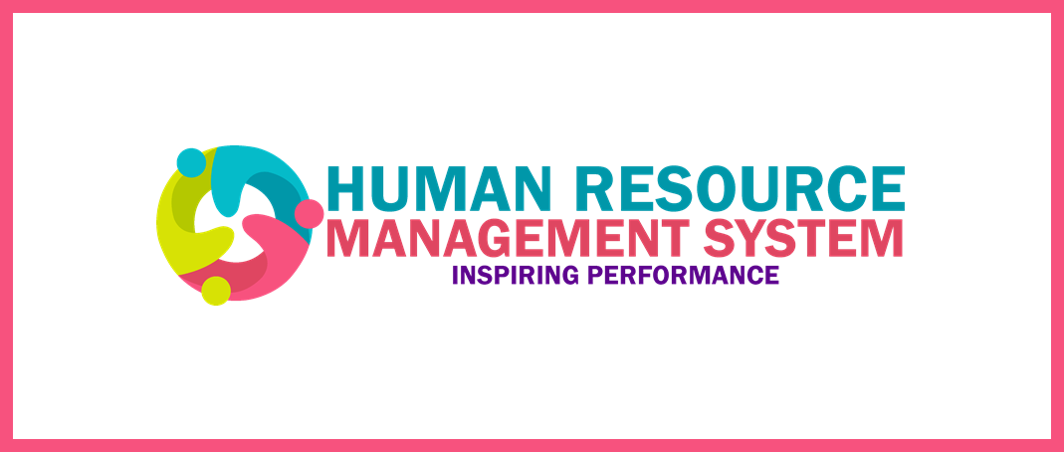

In our last communiqué, we shared with you a sneak peek of the new system from the Manager Direct Access (MDA) perspective, previewing the different functionality that the Manager can perform on HRMS.

Now, let’s watch a short video which highlights the benefits of Guided Learning and how it will simplify learning for you. Guided Learning is an in-app solution that provides you and your team with guidance via pop-up instructions and explanations within a workflow. Guided Learning helps you complete the work activities easily, without having to exit the workflow to find job aids and other supports. In this way users will learn by doing and this always helps to accelerate end user adoption.

Click here to start the video

Keep a lookout for our upcoming communique announcements where we will be sharing more details with you regarding upcoming events, training sessions and the Go-Live date.

HRMS Team

Have you missed our previous announcements?
Don’t know what HRMS is?

The Human Resource Management System (HRMS), is a new Human Capital Management fully integrated, cloud based system that will replace Humber's existing legacy system. The new HRMS will serve as a central source of information for all HR related processes and programs, making it accessible to staff, faculty and other stakeholders through their computer, on or off campus.

Once deployed, the new HRMS provides access to core HR functions, based on your profile as a manager or an employee. Some functionality includes:

- Entering and tracking attendance
- Benefits enrollment
- Entering and approving time
- Talent management (Which includes Recruitment)

And much more!

This would allow HR to:

- Become Better business partners to faculties and departments
- Deliver real-time data & information that will improve decision-making
- Have enhanced reporting capability
- Streamline processes to enable faster transactions

For managers and employees, the direct access functionality will become the new way of interacting with HR giving you the flexibility, autonomy and a sense of ownership for a better overall manager and employee experience.

As we get ready to ‘Go Live’ all impacted stakeholders will be receiving training information to ensure that the transition to the new HRMS is easy and seamless.

To find out more about the HRMS, contact the HRMS Change Management Team at HRMSChangeTeam@humber.ca

