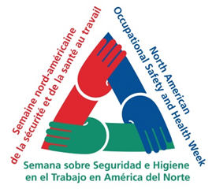

NAOSH SAFETY WEEK
How do You Demonstrate Safety?

To help commemorate NAOSH Week at Humber let us know some actions/activities you have done this past week that promote health and safety at Humber and help to keep you and/or our Humber community safe.

All responses received by Health and Safety Services by 5:00 pm on Monday, May 14, 2018 will be placed in a draw for a chance to win a draw prize.

The name of the winner will be published in the Humber Communiqué on the week of May 21, 2018. Health and Safety Services plans to also share excerpts from some of the responses received. We thank you for your health and safety commitment.

To submit your entry, please complete this form and submit it to Health and Safety Services by emailing healthandsafety@humber.ca by 5 pm on May 14, 2018.

Please describe an action or activity you have done to demonstrate your commitment to safety while working at Humber (pictures may be included in the submission along with the description).

☐ Yes, please share my name and excerpts from my safe activity submission in the Communiqué.

Contact Information:
First Name: | Last Name:
Job Title: | School or Department:
Campus/Room Location:

Email: | Phone Number:

Thank You for your Submission
Good LUCk!

