ZOOM Changing Background Before a Meeting

- Sign in to the Zoom desktop client.
- Click your profile picture, then click Settings.
- Select Virtual Background.
Note: If you do not have the Virtual Background tab and you have enabled it on the web portal, sign out of the Zoom Desktop Client and sign in again.
- Click on an image to select the desired virtual background or add your own image by clicking + and choosing if you want to upload an image.
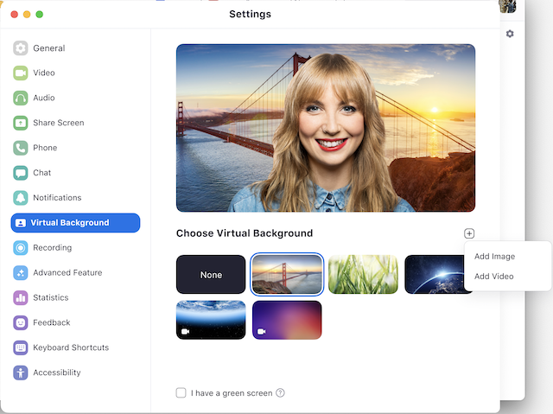

Enabling Virtual Background during a meeting

If you have already have Virtual Background enabled in the web portal, you can turn it on during a meeting.

Zoom Desktop Client
- In a Zoom meeting, click the upward arrow (^) next to Start/Stop Video.
- Click Choose Virtual Background....


