# OSAP and Disability-Related Funding

This document contains information regarding OSAP and Disability-Related Funding based on a video produced on this content.  Below you will find images of a PowerPoint presentation and all information contained in the images as a transcript below each slide.

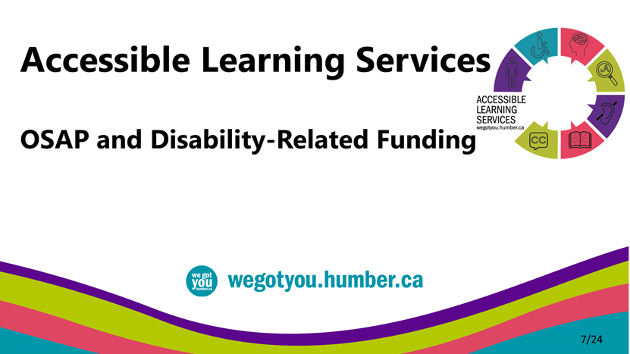

* This is designed to introduce you to common questions about funding opportunities that you can go through at your own pace.  We have provided options for perceiving this content in the spirit of universal design for learning.

## Ontario Student Assistance Program (OSAP)  OSAP slide image: all information in slide provided below.

* OSAP or Ontario Student Assistance Program is a financial aid program that can help you pay for college or university.
* OSAP offers funding through grants money you don't have to pay back, and a student loan money you need to repay once you're done school.
* The OSAP Bursaries for Students with Disabilities and Canada Student Grant for students with disabilities funding programs may assist you with obtaining an updated assessment, assistive technology, or other services while you are enrolled in post-secondary studies.
* By submitting an OSAP application, you may be considered for these grants.

## What if I was planning on not taking OSAP loans?

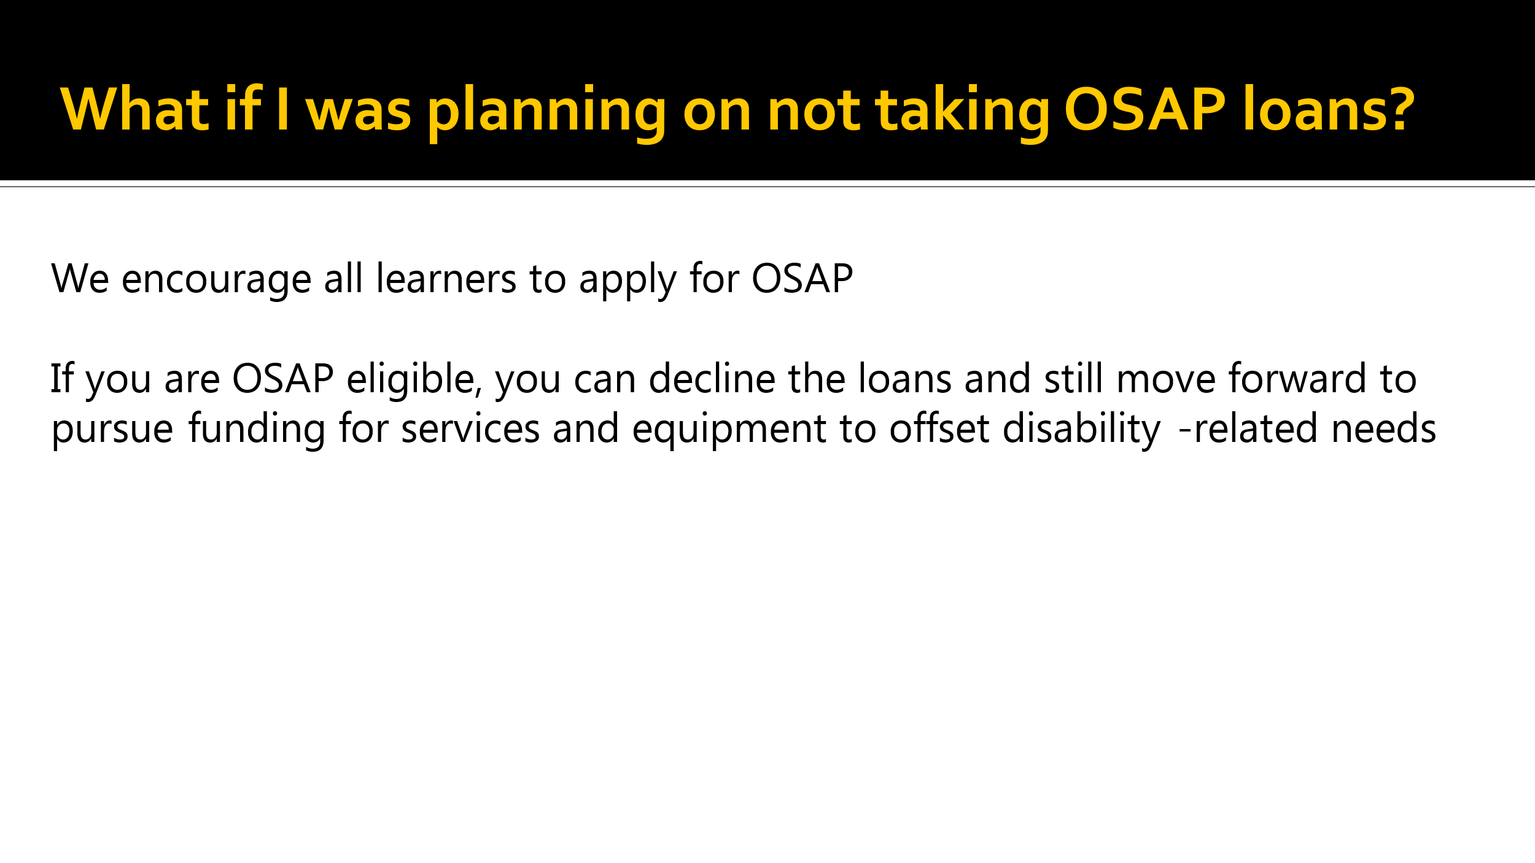

* Even if you were not planning on taking OSAP loans, we encourage all learners to apply for OSAP as it activates consideration for other funding programs besides loans.
* If you are OSAP eligible, you can decline the loans and still move forward to work on disability-specific funding that your Accessibility Consultant recommends to you such as BSWD and CSG.

## How do I apply for OSAP?

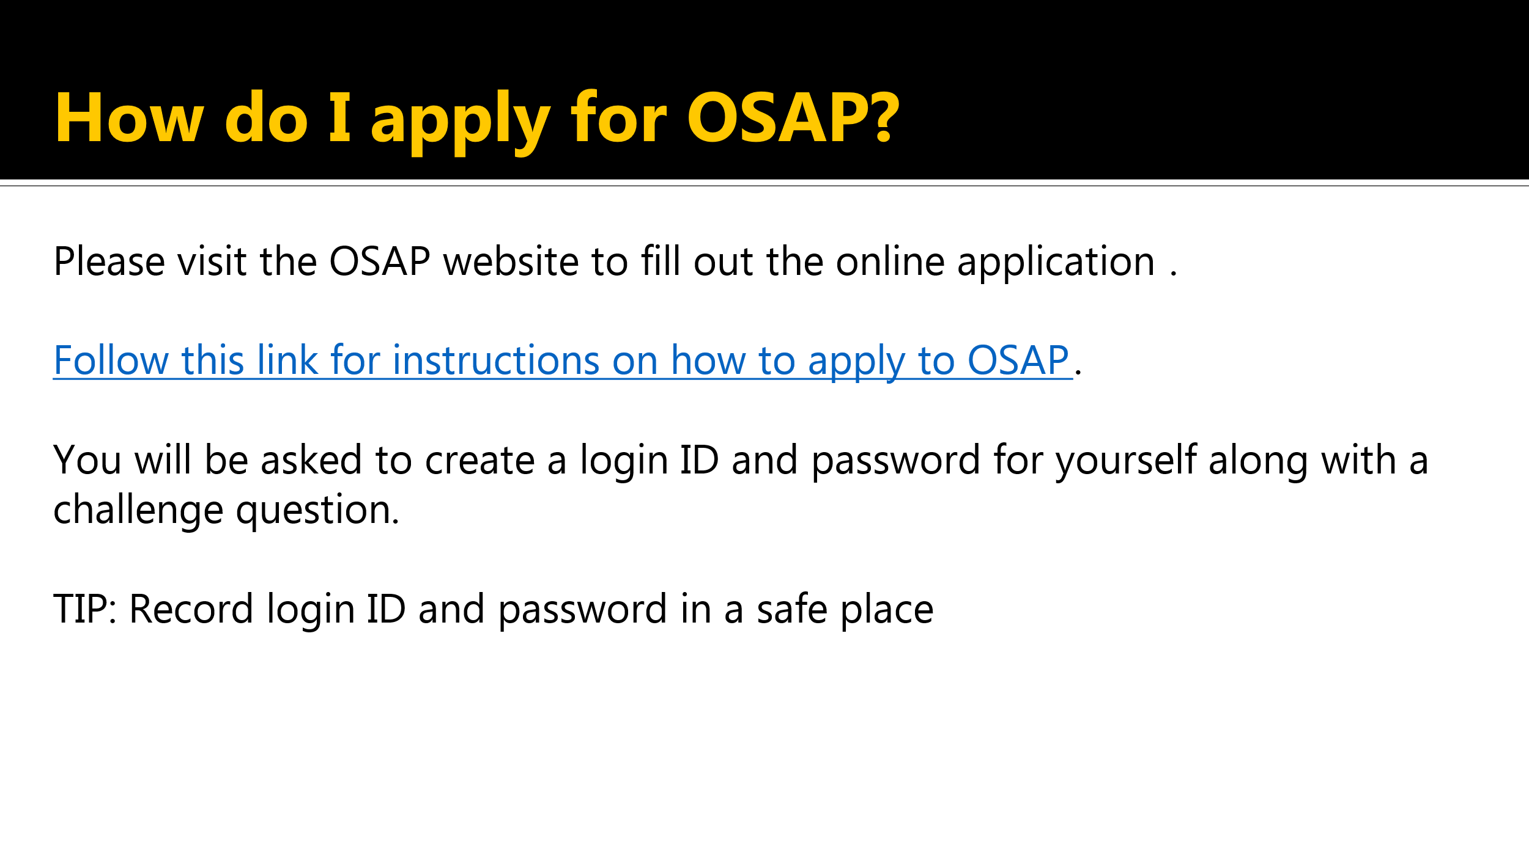

* You apply for OSAP by [following this link for instructions on how to apply for OSAP.](https://www.ontario.ca/page/how-apply-osap)
* You will be asked to create a login ID and password for yourself, along, as well as a challenge question.
* **Important tip**: be sure to record your login and password in a safe place as Humber, or Guelph Humber staff are not able to assist you in recovering it.

## What is the OSAP Disability Verification Form?  What is the OSAP Disability Verification Form? slide image: all information in slide provided below.

* If you are a learner with a permanent or persistent and prolonged disability, you may be eligible for disability-specific grants and bursaries to access these funding opportunities.
* A regulated health care professional must complete the OSAP Disability Verification Form (DVF).
* A pre-filled version with your information can be downloaded from your online OSAP or follow this link for a [blank version of the Disability Verification Form](https://osap.gov.on.ca/OSAPPortal/en/PostsecondaryEducation/OSAP/Forms/index.htm).
* **Important tip**: make sure to select the current academic year and the version for students attending Ontario public post-secondary institutions.

## OSAP Disability Verification Form - SampleOSAP Disability Verification Form -Sample slide image: all information in slide provided below.

* Here is a sample of the Disability Verification Form.
* The first section contains basic personal information.
* The next section, labelled part one, gives a location for the Physician or regulated health care professional to enter their information and profession or specialty.
* Part three contains information about the nature of an individual's disability and functional impacts.

OSAP Disability Verification Form and Learning Disabilities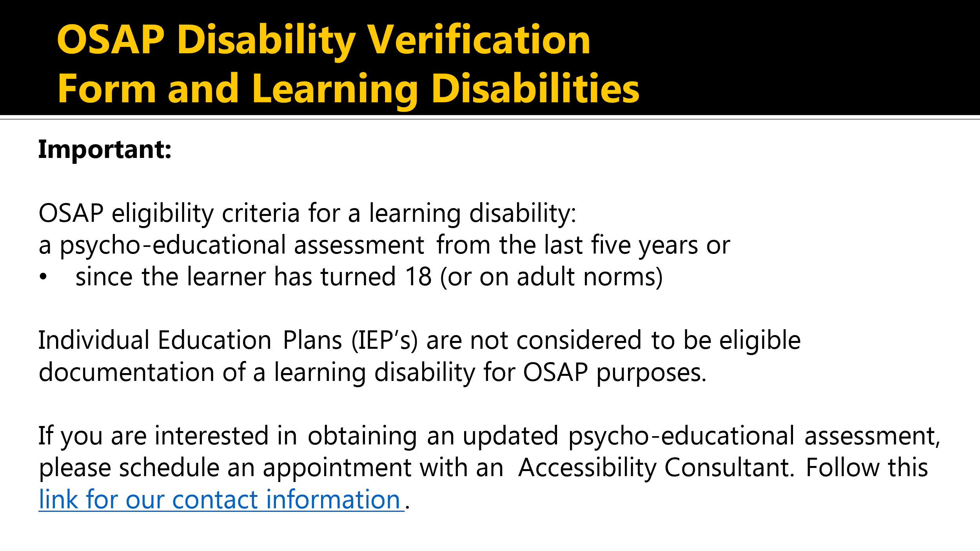

* It is important to note that if you are confirming disability status on the basis of a learning disability, OSAP eligibility criteria require that a psycho-educational assessment must have been performed in the last five years or since a student has turned 18.
* Individual education plans, or IEPs, are not considered to be eligible.
* If you are interested in obtaining an updated psycho-education assessment, please schedule an appointment with an Accessibility Consultant.
* Follow this [link for our contact information](https://humber.ca/student-life/swac/contact-us/accessible-learning-services-campus-contact-information).

## How can I access OSAP bursaries and grants?

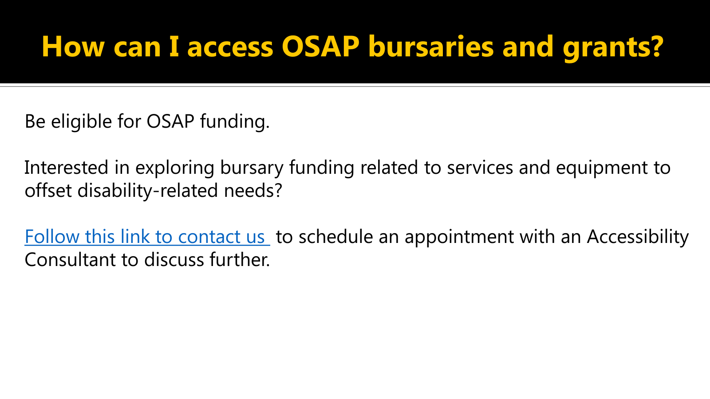

* How can I access OSAP bursaries and grants?
* You must be eligible for OSAP funding.
* You may be eligible for an annual federal grant because you apply for OSAP and have an approved Disability Verification Form in place.
* If you are interested in exploring bursary funding related to services and equipment to offset disability-related needs, please schedule an appointment by [following this link](https://humber.ca/student-life/swac/contact-us/accessible-learning-services-campus-contact-information) to meet with an Accessibility Consultant to discuss further.

## Who can help if I am having problems applying for OSAP?

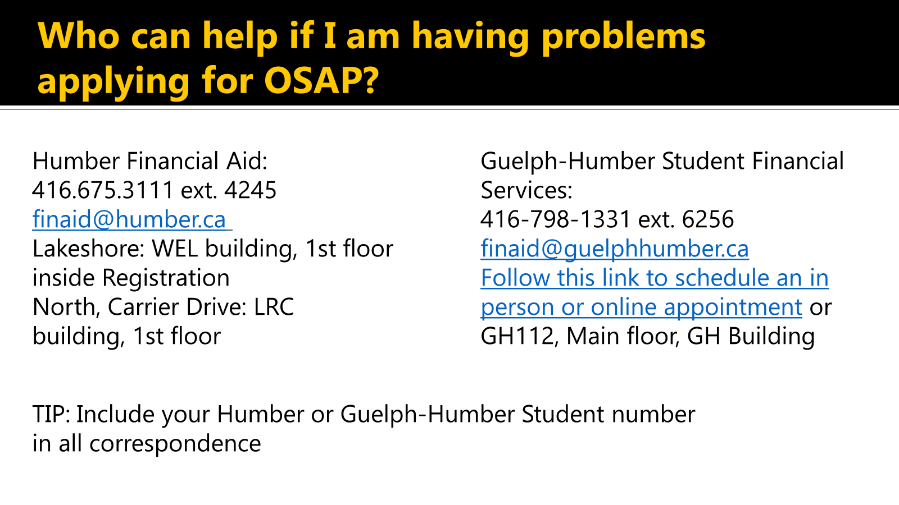

* If you need help applying for OSAP because you are having difficulties, you can contact financial aid or Student Financial Services.
* Humber Financial Aid can be reached by telephone at (416) 675-3111 extension 4245 to request an appointment.
* They can also be reached by email at [finaid@humber.ca](mailto:finaid@humber.ca)
* Guelph Humber Student Financial Services can be contacted by phone at (416) 798-1331, extension 6256 or by email at [finaid@guelphhumber.ca](mailto:finaid@guelphhumber.ca)
* [Follow this link to schedule an appointment in person or online](https://outlook.office365.com/owa/calendar/StudentFinancialServices1@uoguelphca.onmicrosoft.com/bookings/).

## Questions about Accessible Learning Services?Questions about Accessible Learning Services? slide image: all information in slide provided below.

* Do you have questions about Accessible Learning Services?
* You can contact us by phone at the North Campus at (416) 675-5090, or Lakeshore Campus at (416) 675-6622, extension 3331.
* You can also contact us by email at [accessible-learning@humber.ca](mailto:accessible-learning@humber.ca)
* Please visit [Accessible Learning Services website](https://humber.ca/student-life/swac/accessible-learning) for lots of helpful information.
* We appreciate that your situation is unique to you.
* An individualized planning may be required.