# Reasons for Confirming Disability Status

This document contains information regarding Reasons for Confirming Disability Status based on a video produced on this content.  Below you will find images of a PowerPoint presentation and all information contained in the images as a transcript below each slide.

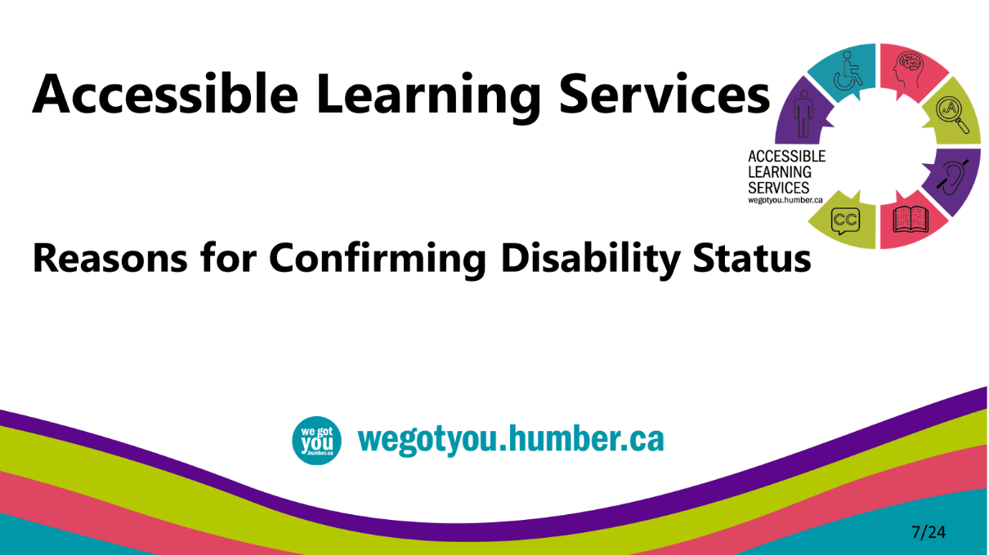

* Welcome, this document is intended to introduce you to common questions about providing documentation to confirm disability status that you can go through at your own pace. We have provided options for perceiving this content in the spirit of universal design for learning.

## Reasons for Providing Disability Documentation

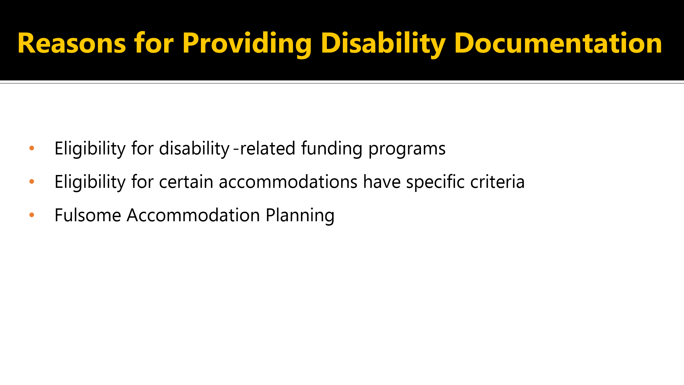

* Learners may decide to provide disability documentation if they are interested in certain funding programs, such as the tuition cap, Bursaries for Students with Disabilities, and the Canadian Studies Grant.
* Eligibility for certain accommodations have specific requirements; for example, learners who require the services of an ASL interpreter may be requested to provide a copy of an audiogram or an Audiologist report.
* It also allows for fulsome accommodation planning.

## How is documentation used in Accommodation Planning?

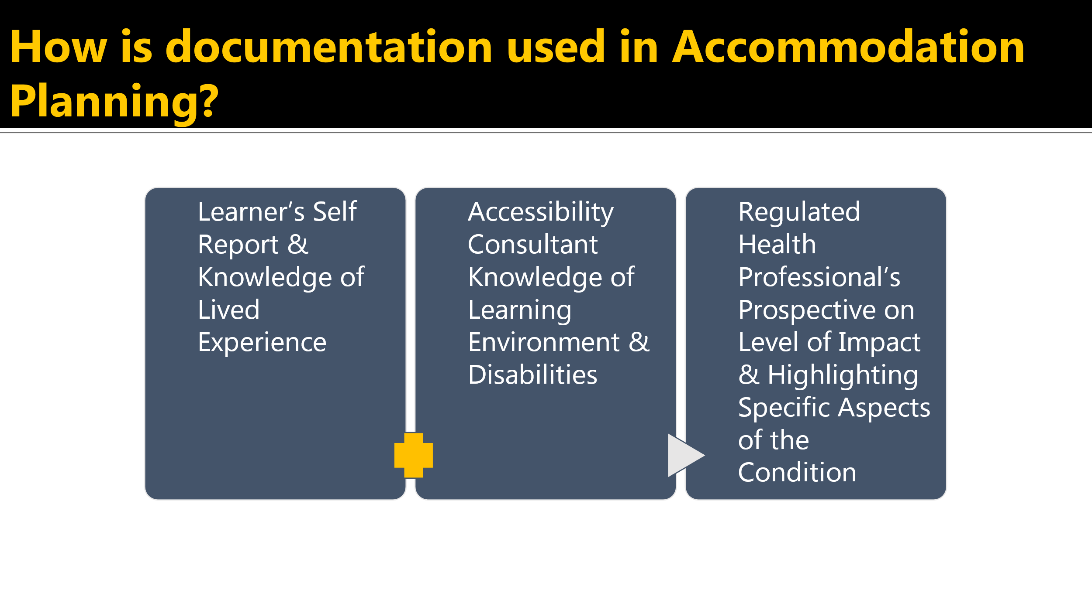

* How is documentation used in accommodation planning?
* Accessibility Consultants work with learners to determine academic accommodations based on disability-related need as described through your self-report combined with the Accessibility Consultant's knowledge of disabilities and learning environment.
* Documentation outlining the functional impacts of your disability will help us understand your strengths and challenges so that we can determine the most appropriate accommodations to support you accessing the learning environment.
* In accordance with the Ontario Human Rights Code, you are not required to disclose your specific diagnosis to accessible learning services to receive accommodations.

## Confidentiality

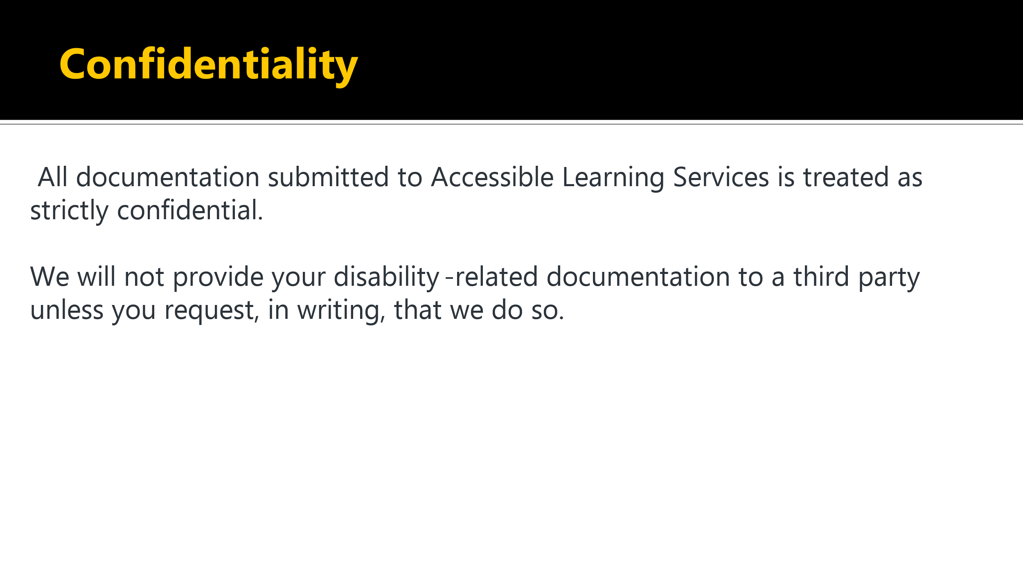

* Note that all documentation submitted to Accessible Learning Services is treated as strictly confidential.
* We will not provide your disability-related documentation to a third party unless you request in writing that we do so.

## Types of Documentation by Disability Category

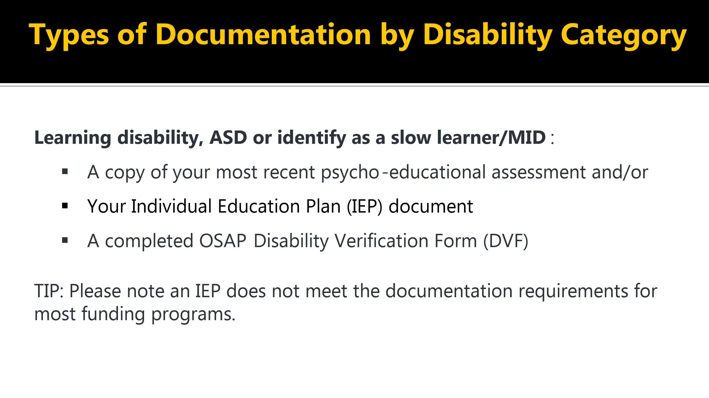

* If you are a person with a learning disability, ASD, or identify as a slow learner/MID, please provide a copy of your most recent psycho-educational assessment and or your
* Individual Education Plan or IEP document, a completed OSAP Disability Verification Form.
* Please note that an IEP does not meet the documentation requirements for most funding programs.

## Types of Documentation by Disability Category

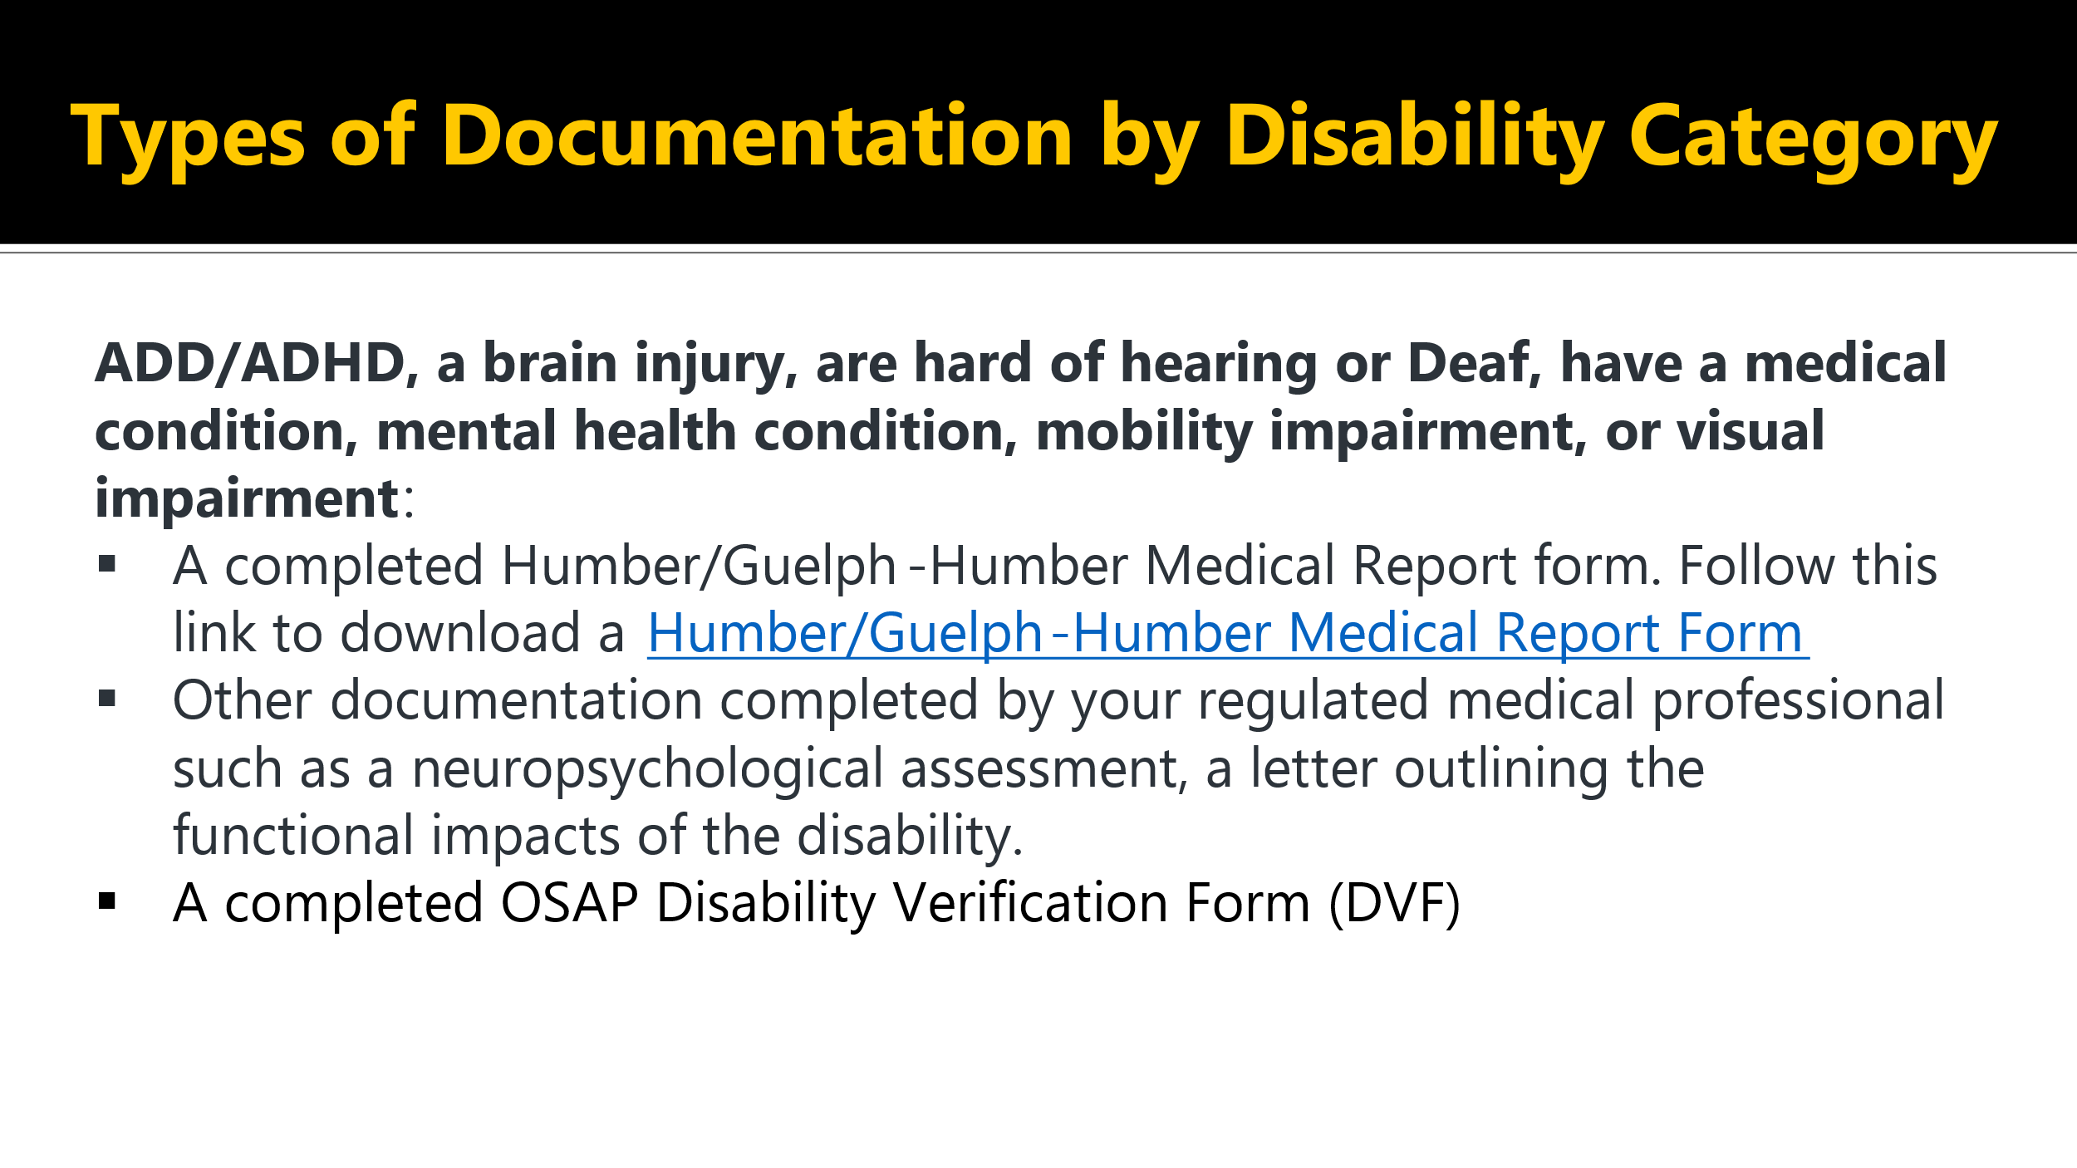

* If you are a student with ADD, ADHD, a brain injury, or hard of hearing or Deaf, have a medical condition, mental health condition, mobility impairment or visual impairment. please download and complete the [Humber/Guelph-Humber Medical Report Form.](https://humber.ca/student-life/swac/sites/default/files/ALS_Medical%20Report%20Form.pdf)
* Other documentation completed by your health care professional, such as a neuropsychological assessment, a letter outlining the functional impacts of your disability, and a completed OSAP Disability Verification Form will be required.

## Forms TIP

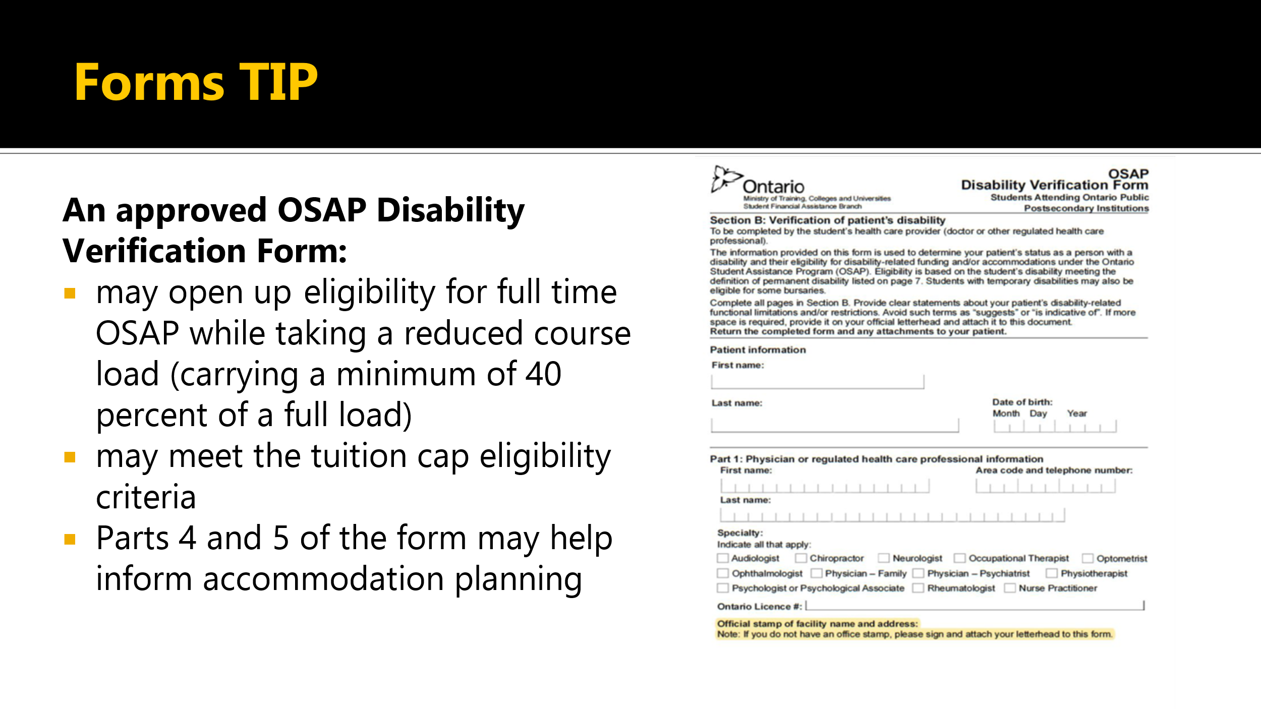

* **Tip:** if you need a regulated health care professional to complete a form, the OSAP Disability Verification Form serves multiple purposes.
* An approved OSAP Disability Verification Form that confirms the presence of a permanent or persistent and prolonged condition may open up eligibility for full-time OSAP while taking a reduced course load, carrying a minimum of 40% of a load.
* This form can also be reviewed by an Accessibility Consultant for tuition cap eligibility.
* Parts four and five of the form may help inform accommodation planning completed by you and an Accessibility Consultant.
* Please follow this link for the [OSAP Disability Verification Form.](https://osap.gov.on.ca/prdosapconsum/groups/forms/documents/forms/pocont1_086272.pdf)
* There is a section at the top for your personal information and a section for the physician or regulated health care professional to enter their information and specify their discipline and to complete the part regarding the nature of the individual's disability and its impacts.

## What if I do not have documentation?

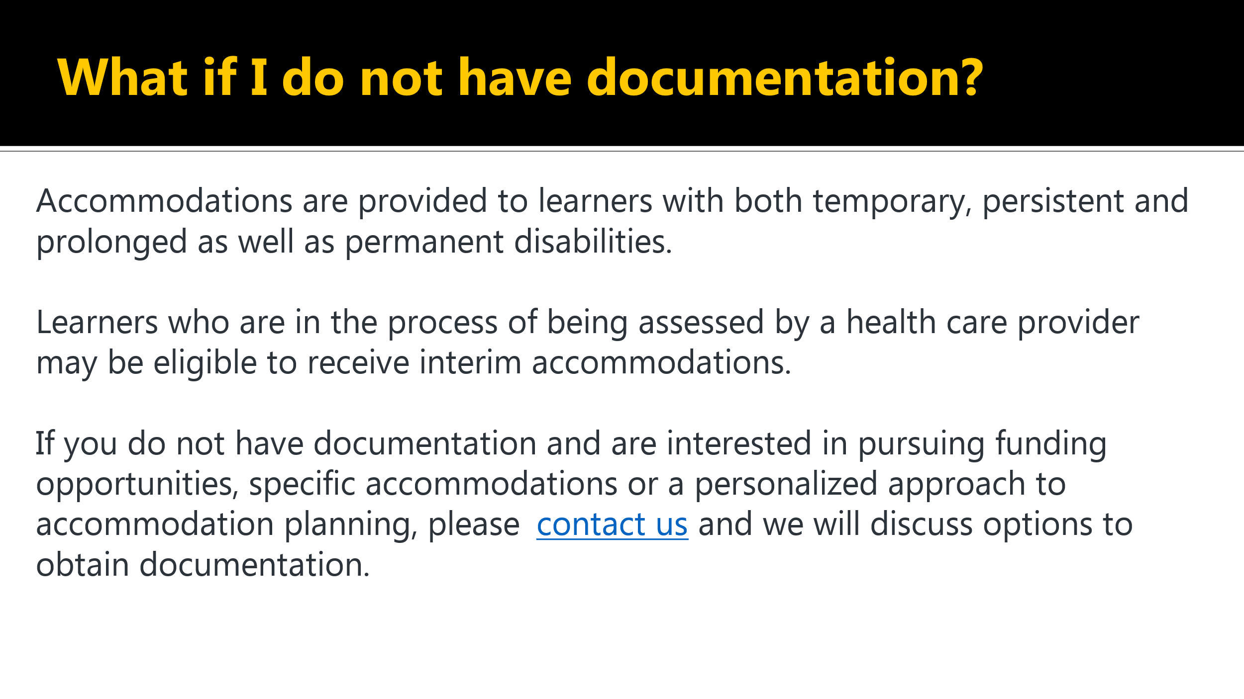

* Accommodations are provided to learners with both temporary, persistent, and prolonged, as well as permanent disabilities.
* Learners who are in the process of being assessed by a health care provider may be eligible to receive interim accommodations.
* If you do not have documentation and are interested in pursuing funding opportunities for specific accommodations or a personalized approach to accommodation planning, please [contact us](https://humber.ca/student-life/swac/contact-us/accessible-learning-services-campus-contact-information) to schedule an appointment with an Accessibility Consultant to discuss options to obtain documentation.

## What if my learning disability documentation is more than five years old?

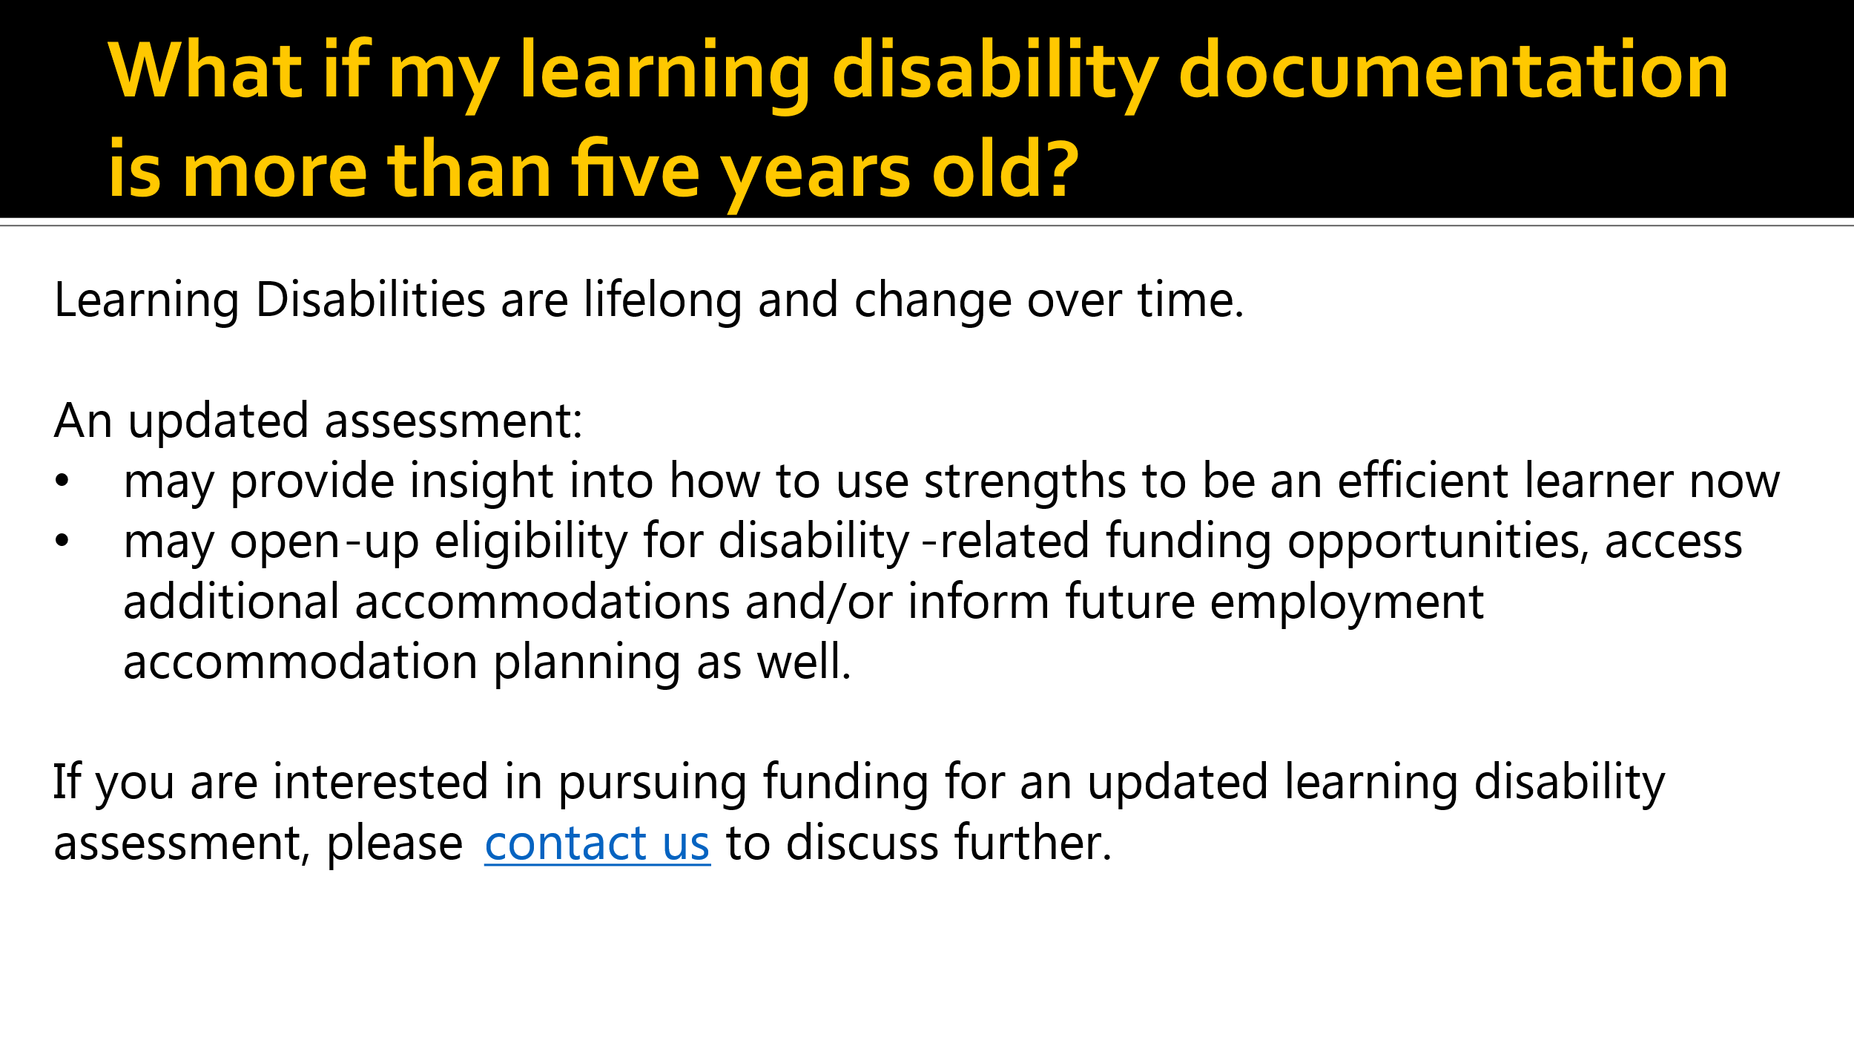

* Learning disabilities change over time as you have progressed through the education system.
* Often, learners identified in childhood or adolescence develop ways of working with a learning disability, and your strengths and weaknesses profile may look different now than when you were last assessed.
* Obtaining an updated assessment will give you and your Accessibility Consultant insight into how to use those strengths to be an efficient learner in post-secondary now.
* An updated assessment may open up disability-related funding opportunities, access additional accommodations, and/or inform future employment accommodation planning as well.

## Questions about Accessible Learning Services?

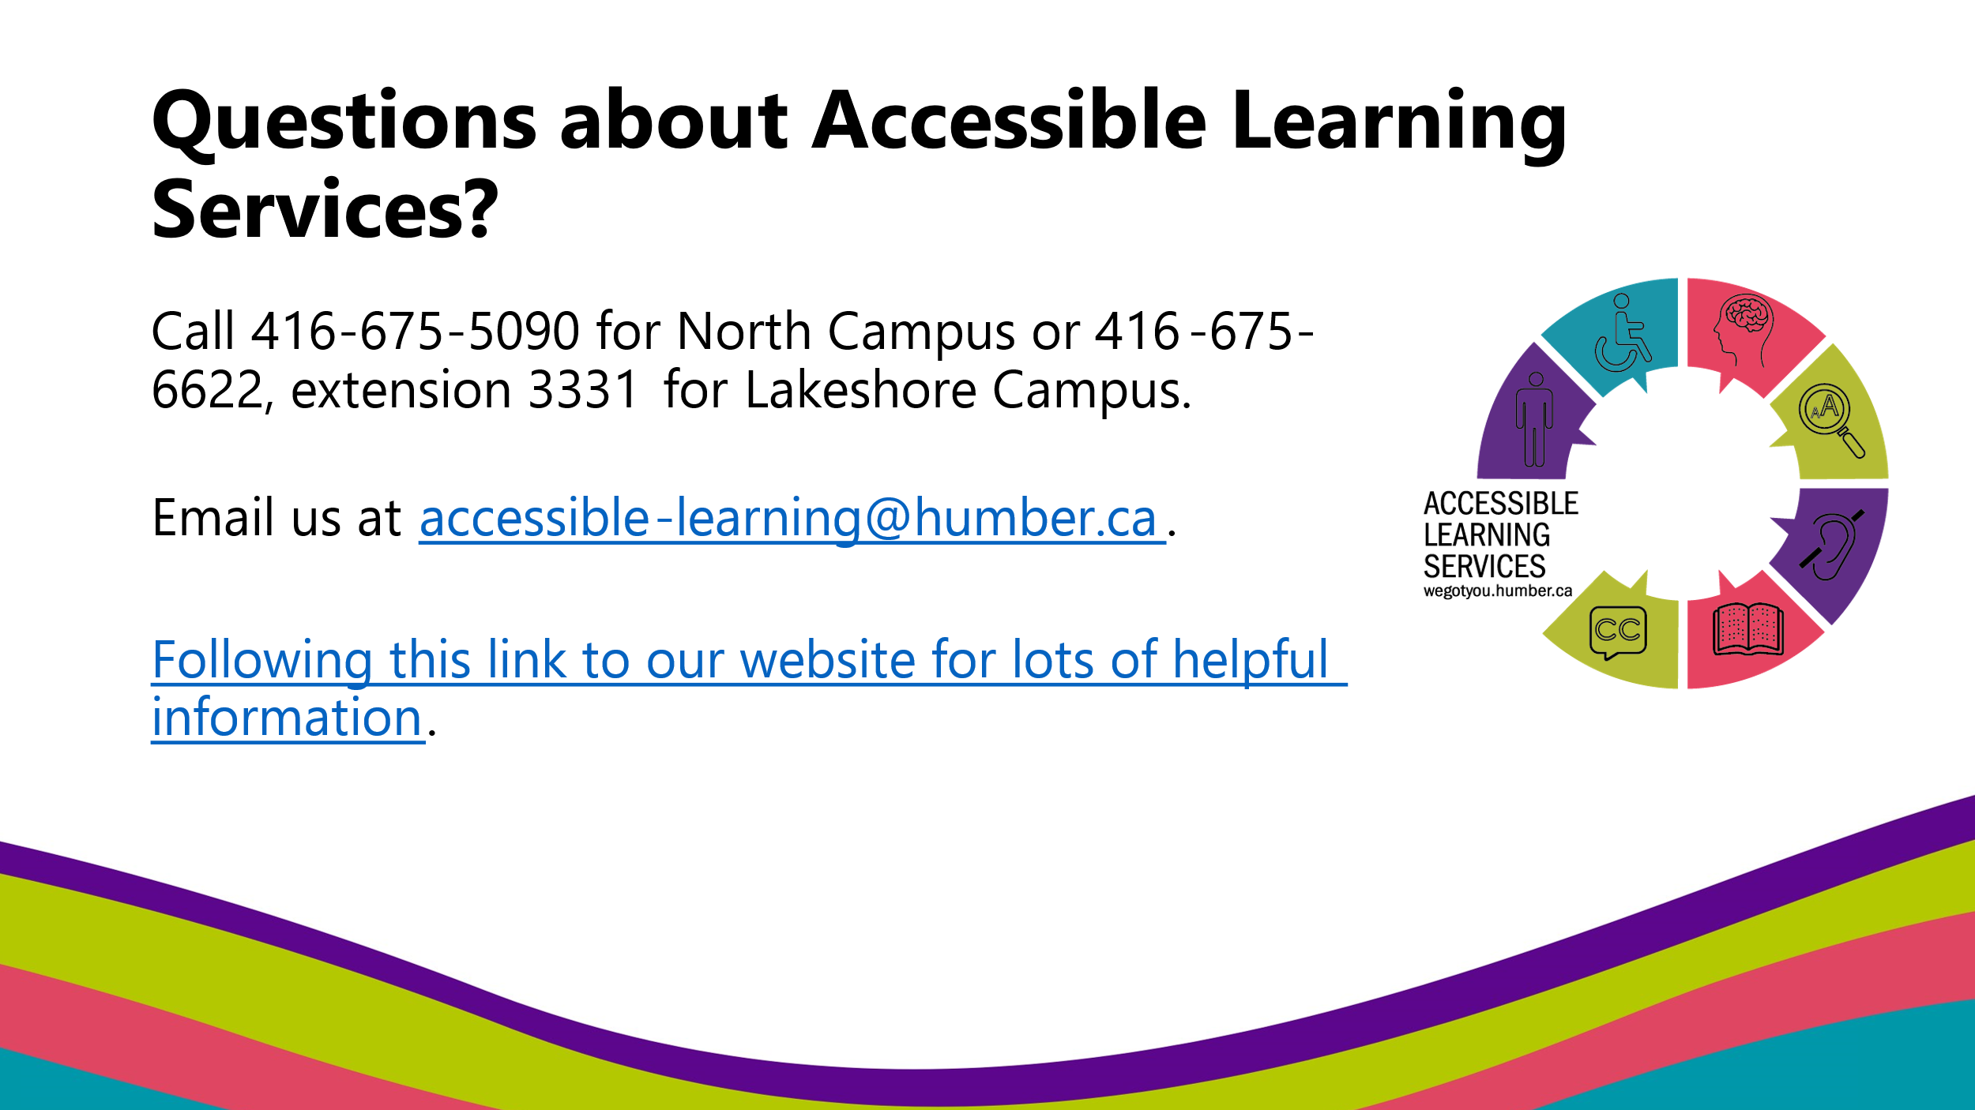

* Do you have questions about Accessible Learning Services?
* You can call our North Campus at (416) 675-5090, or Lakeshore Campus at (416) 675-6622, extension 3331.
* You can also email us at [accessible-learning@humber.ca](mailto:accessible-learning@humber.ca) or [visit our website](https://humber.ca/student-life/swac/accessible-learning) for lots of helpful information.
* We appreciate that your situation is unique to you and individualized planning may be required.