Reduced Course Load and Tuition Cap

This document contains information regarding Reduced Course Load and Tuition Cap based on a video produced on this content.  Below you will find images of a PowerPoint presentation and all information contained in the images as a transcript below each slide.

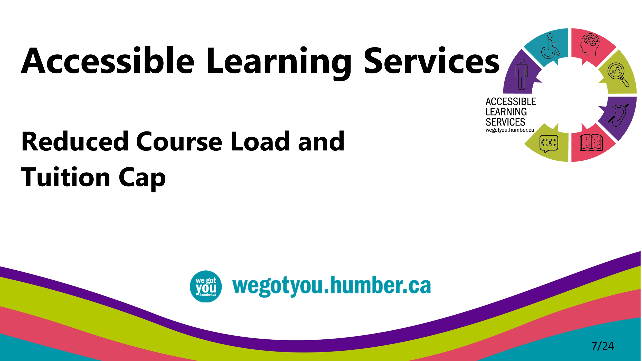

* This video is intended to introduce you to information about reduced course load and tuition cap that you can go through at your own pace.
* We have provided options for perceiving this content in the spirit of universal design.

Reduced Course Load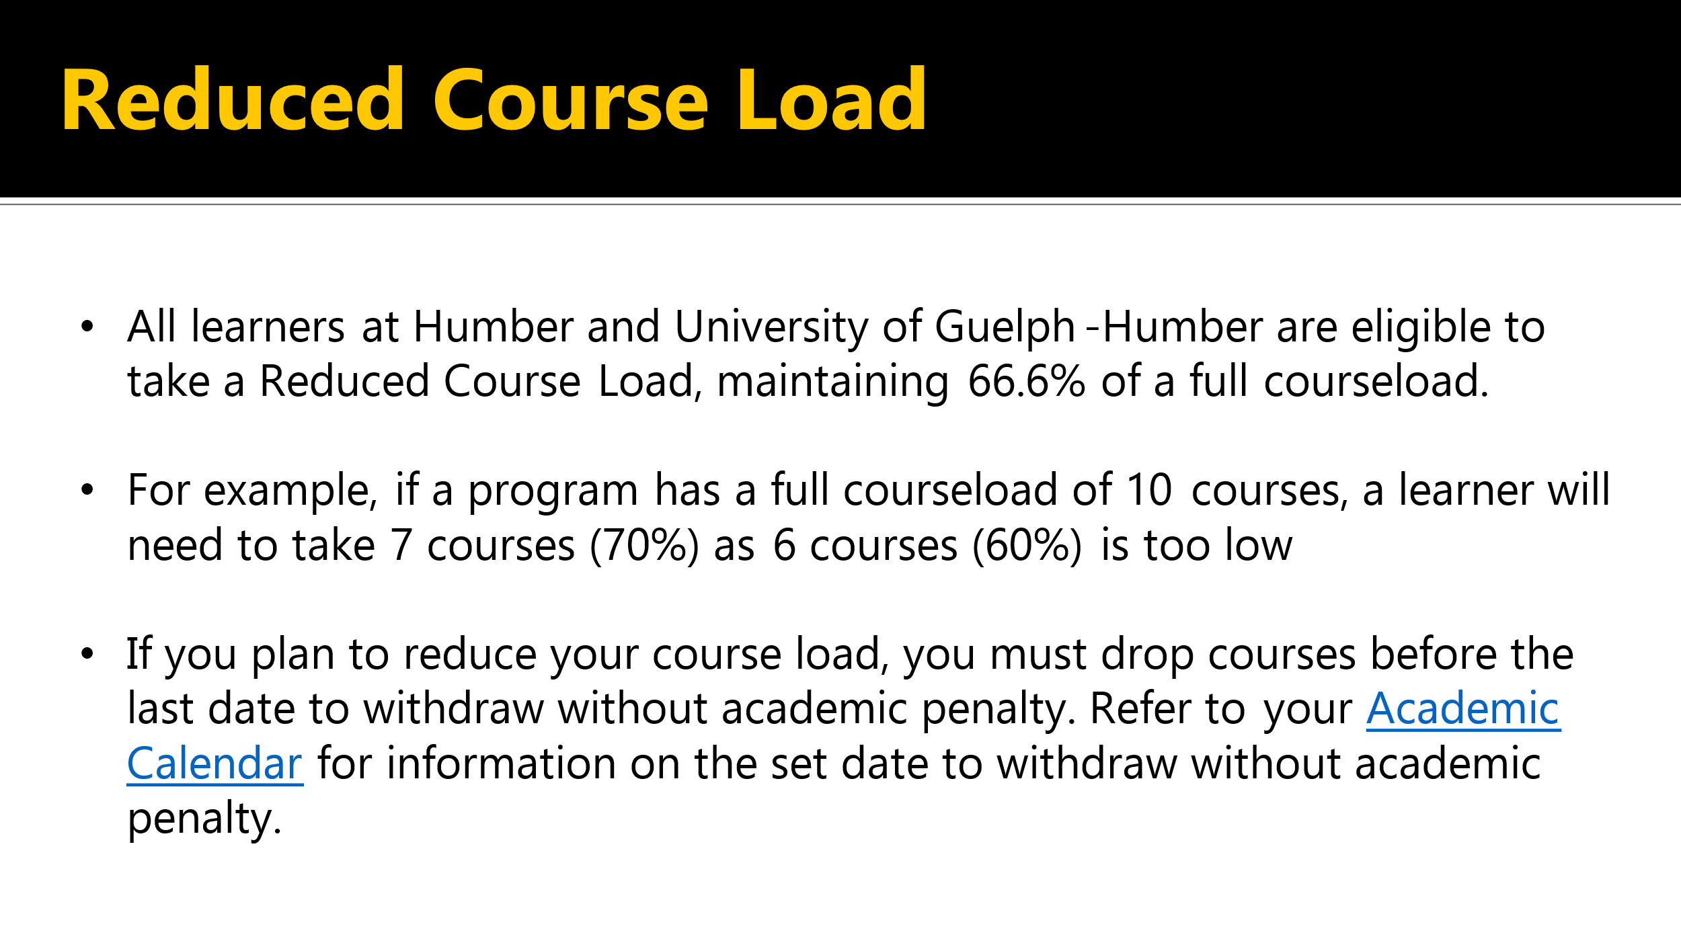

* All learners at Humber and the University of Guelph-Humber are eligible to take a reduced course load, maintaining 66.6% of a full course load.
* For example, if a program has a full course load of ten courses, a learner will need to take seven courses, or 70% as six courses, or 60% is too low.
* If you plan to reduce your course load, you must drop courses before the last date to withdraw with an academic penalty.
* [Please follow this link to the academic calendar](https://humber.ca/admissions/office-of-the-registrar/academic-calendar.html) for information on the set date to withdraw with an academic penalty.

## Documentation Requirements at 40% Minimum Course Load

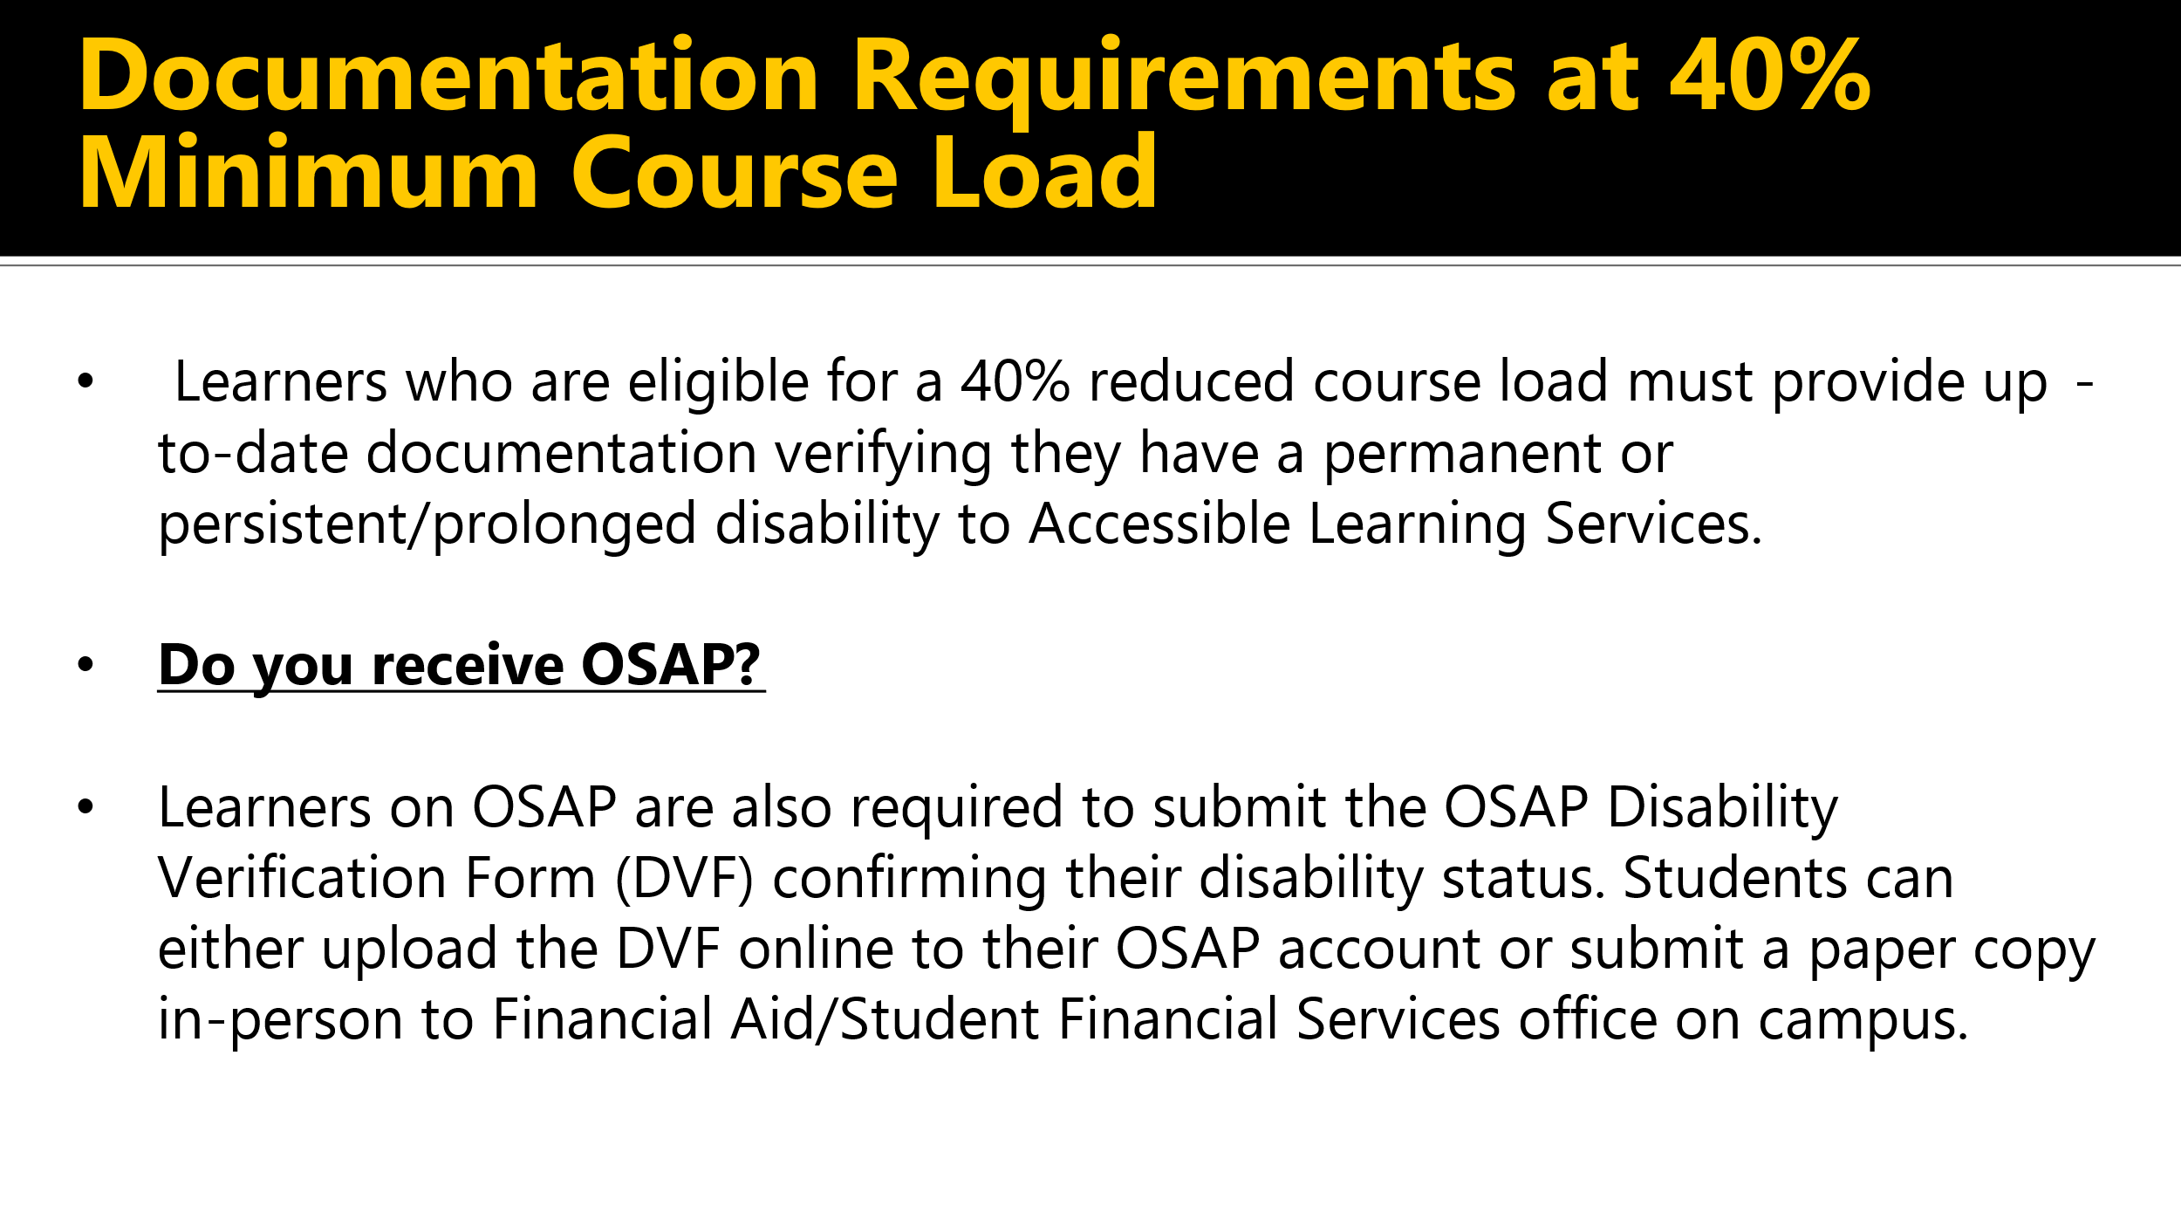

* Learners who are eligible for a 40% reduced course load must provide up-to-date documentation verifying that they have a permanent or persistent and prolonged disability to Accessible Learning Services.
* Learners on OSAP are also required to submit the OSAP Disability Verification Form or DVF, confirming their disability status.
* Students can either upload the DVF online to their OSAP account or submit a paper copy in person to financial aid or Student Financial Services offices on campus.

## Steps to Complete if taking a Reduced Course Load

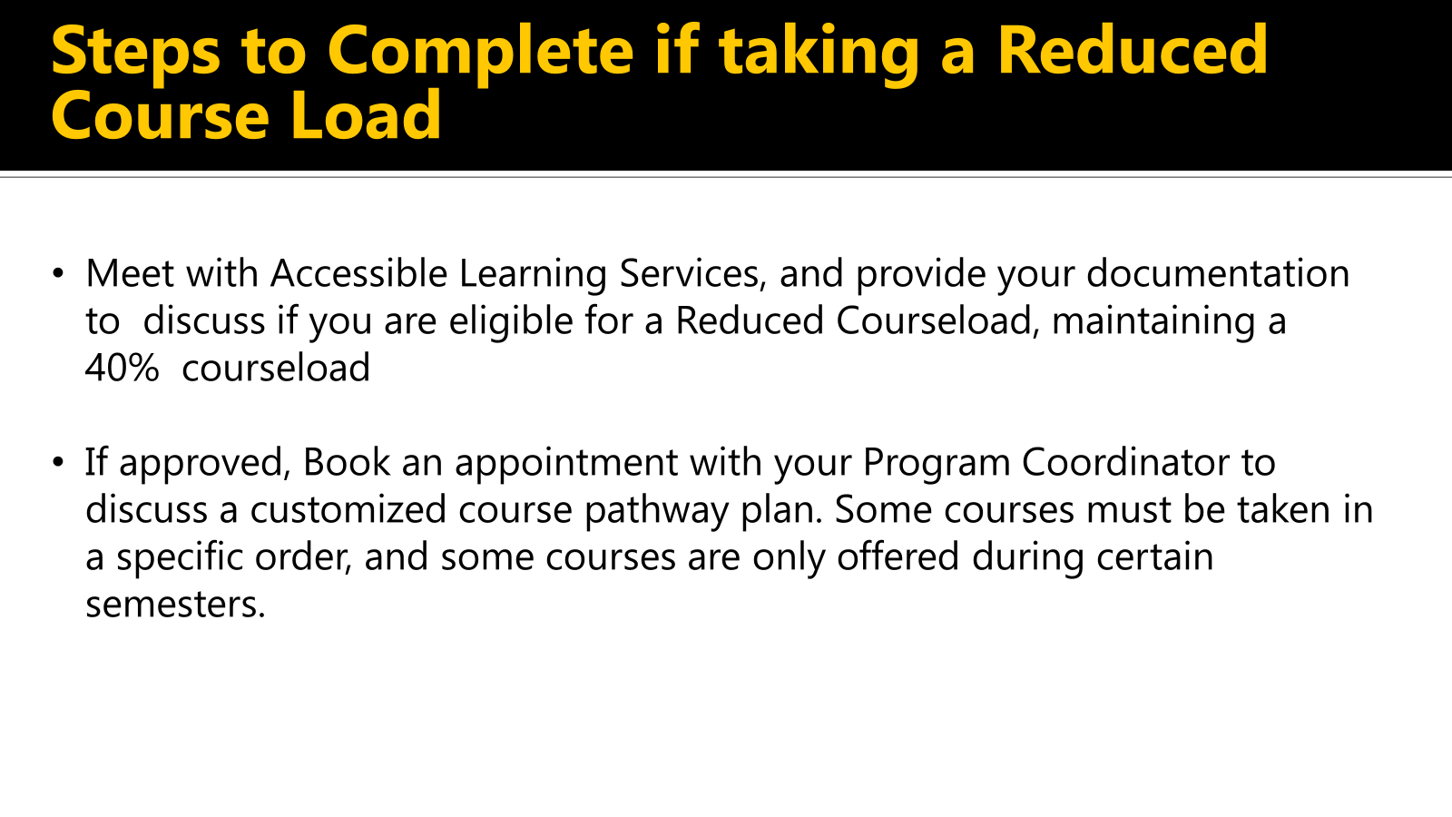

* Steps to complete if taking a reduced course load.
* Meet with Accessible Learning Services and provide your documentation to discuss if you're eligible for a reduced course load, maintaining a 40% course load.
* If approved, book an appointment with your Program Coordinator to discuss a customized course pathway plan.
* Some courses must be taken in a specific order, and some courses are only offered during certain semesters.

## Steps to Complete if taking a Reduced Course Load

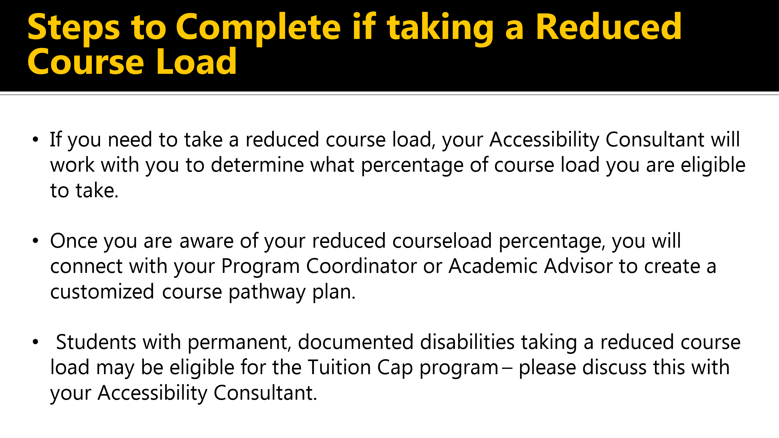

* If you need to take a reduced course load.
* Your Accessibility Consultant will work with you to determine what percentage of course load you are eligible to take.
* Once you are aware of your reduced course load percentage, you will connect with your Program Coordinator or Academic Advisor to create a customized course pathway plan.
* Students with permanent documented disabilities taking a reduced course load may be eligible for the tuition cap program.
* Please discuss this with your Accessibility Consultant.

## Tuition Cap

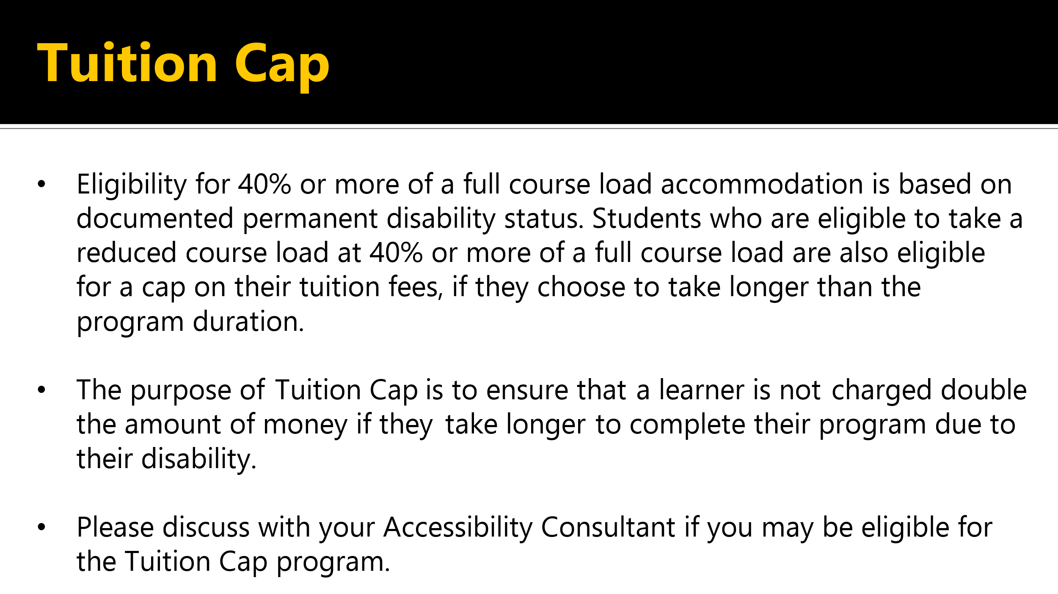

* Eligibility for 40% or more of a full course load accommodation is based on documented permanent disability status.
* Students who are eligible to take a reduced course load at 40% or more of a full course load are also eligible for a cap on their tuition fees if they choose to take longer than the program duration.
* The purpose of tuition cap is to ensure that a learner is not charged double the amount of money if they take longer to complete their program due to their disability.
* Please discuss with your Accessibility Consultant if you may be eligible for the tuition cap program.

## Important Considerations

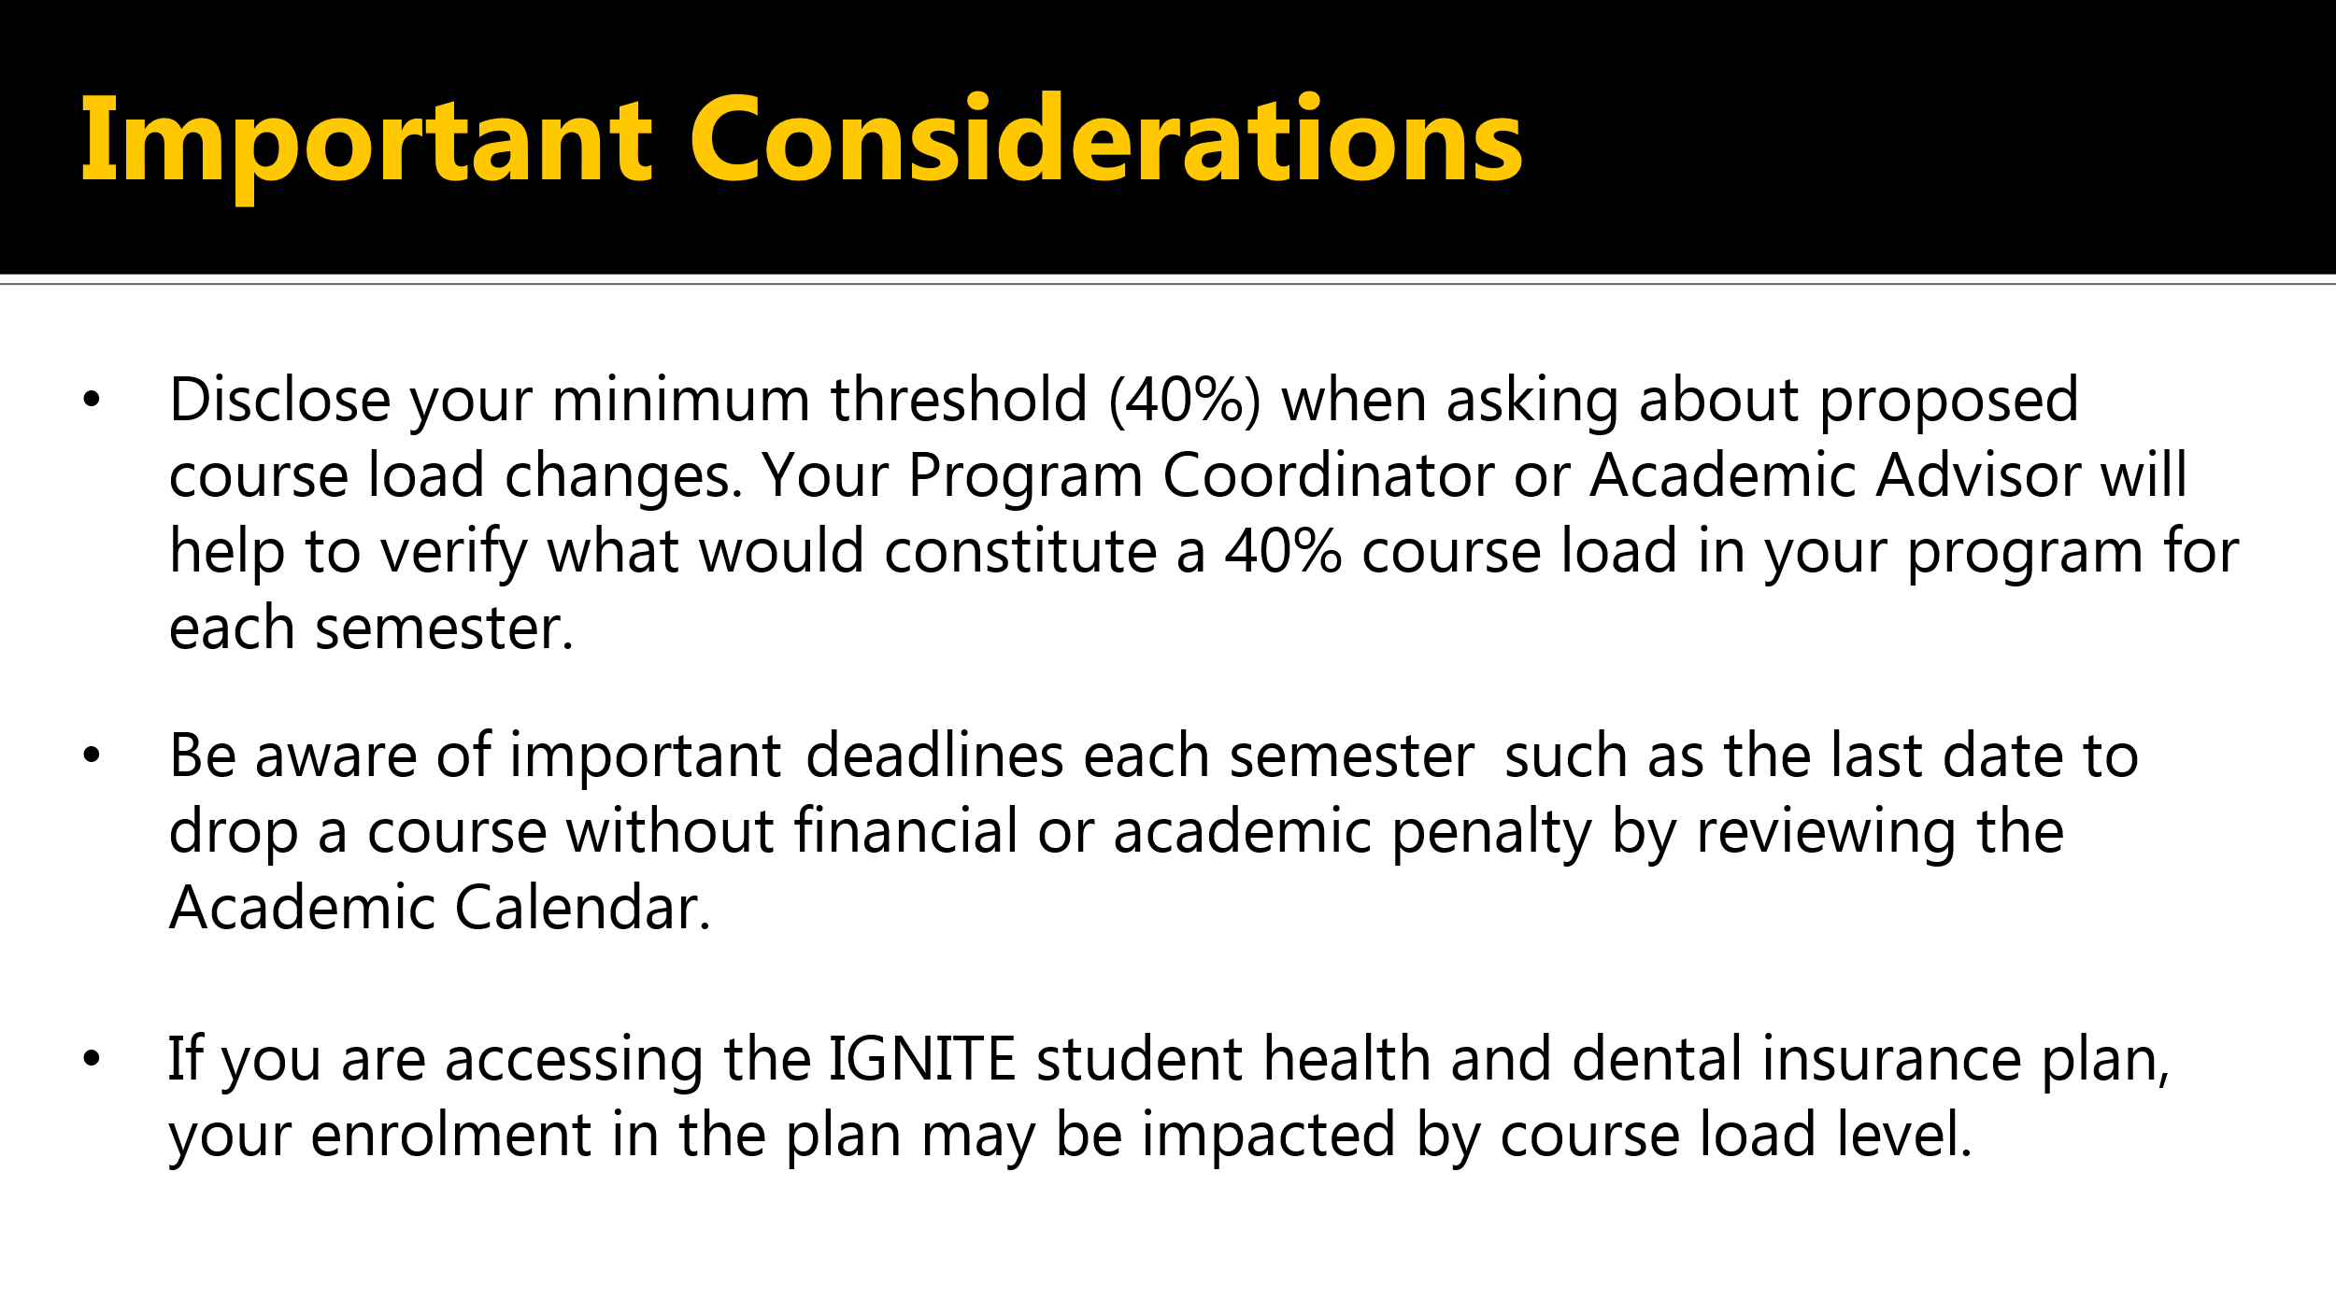

* Disclose your minimum threshold. 40%, when asking about proposed course load changes.
* Your Program Coordinator or Academic Advisor will help to verify what would constitute a 40% course load in your program for each semester.
* Be aware of important deadlines each semester, such as the last date to drop a course with a financial or academic penalty by reviewing [the academic calendar](https://humber.ca/admissions/office-of-the-registrar/academic-calendar.html).
* If you are accessing the Ignite Student Health and Dental Insurance plan, your enrollment in the plan may be impacted by course load level.

## Questions about Accessible Learning Services?

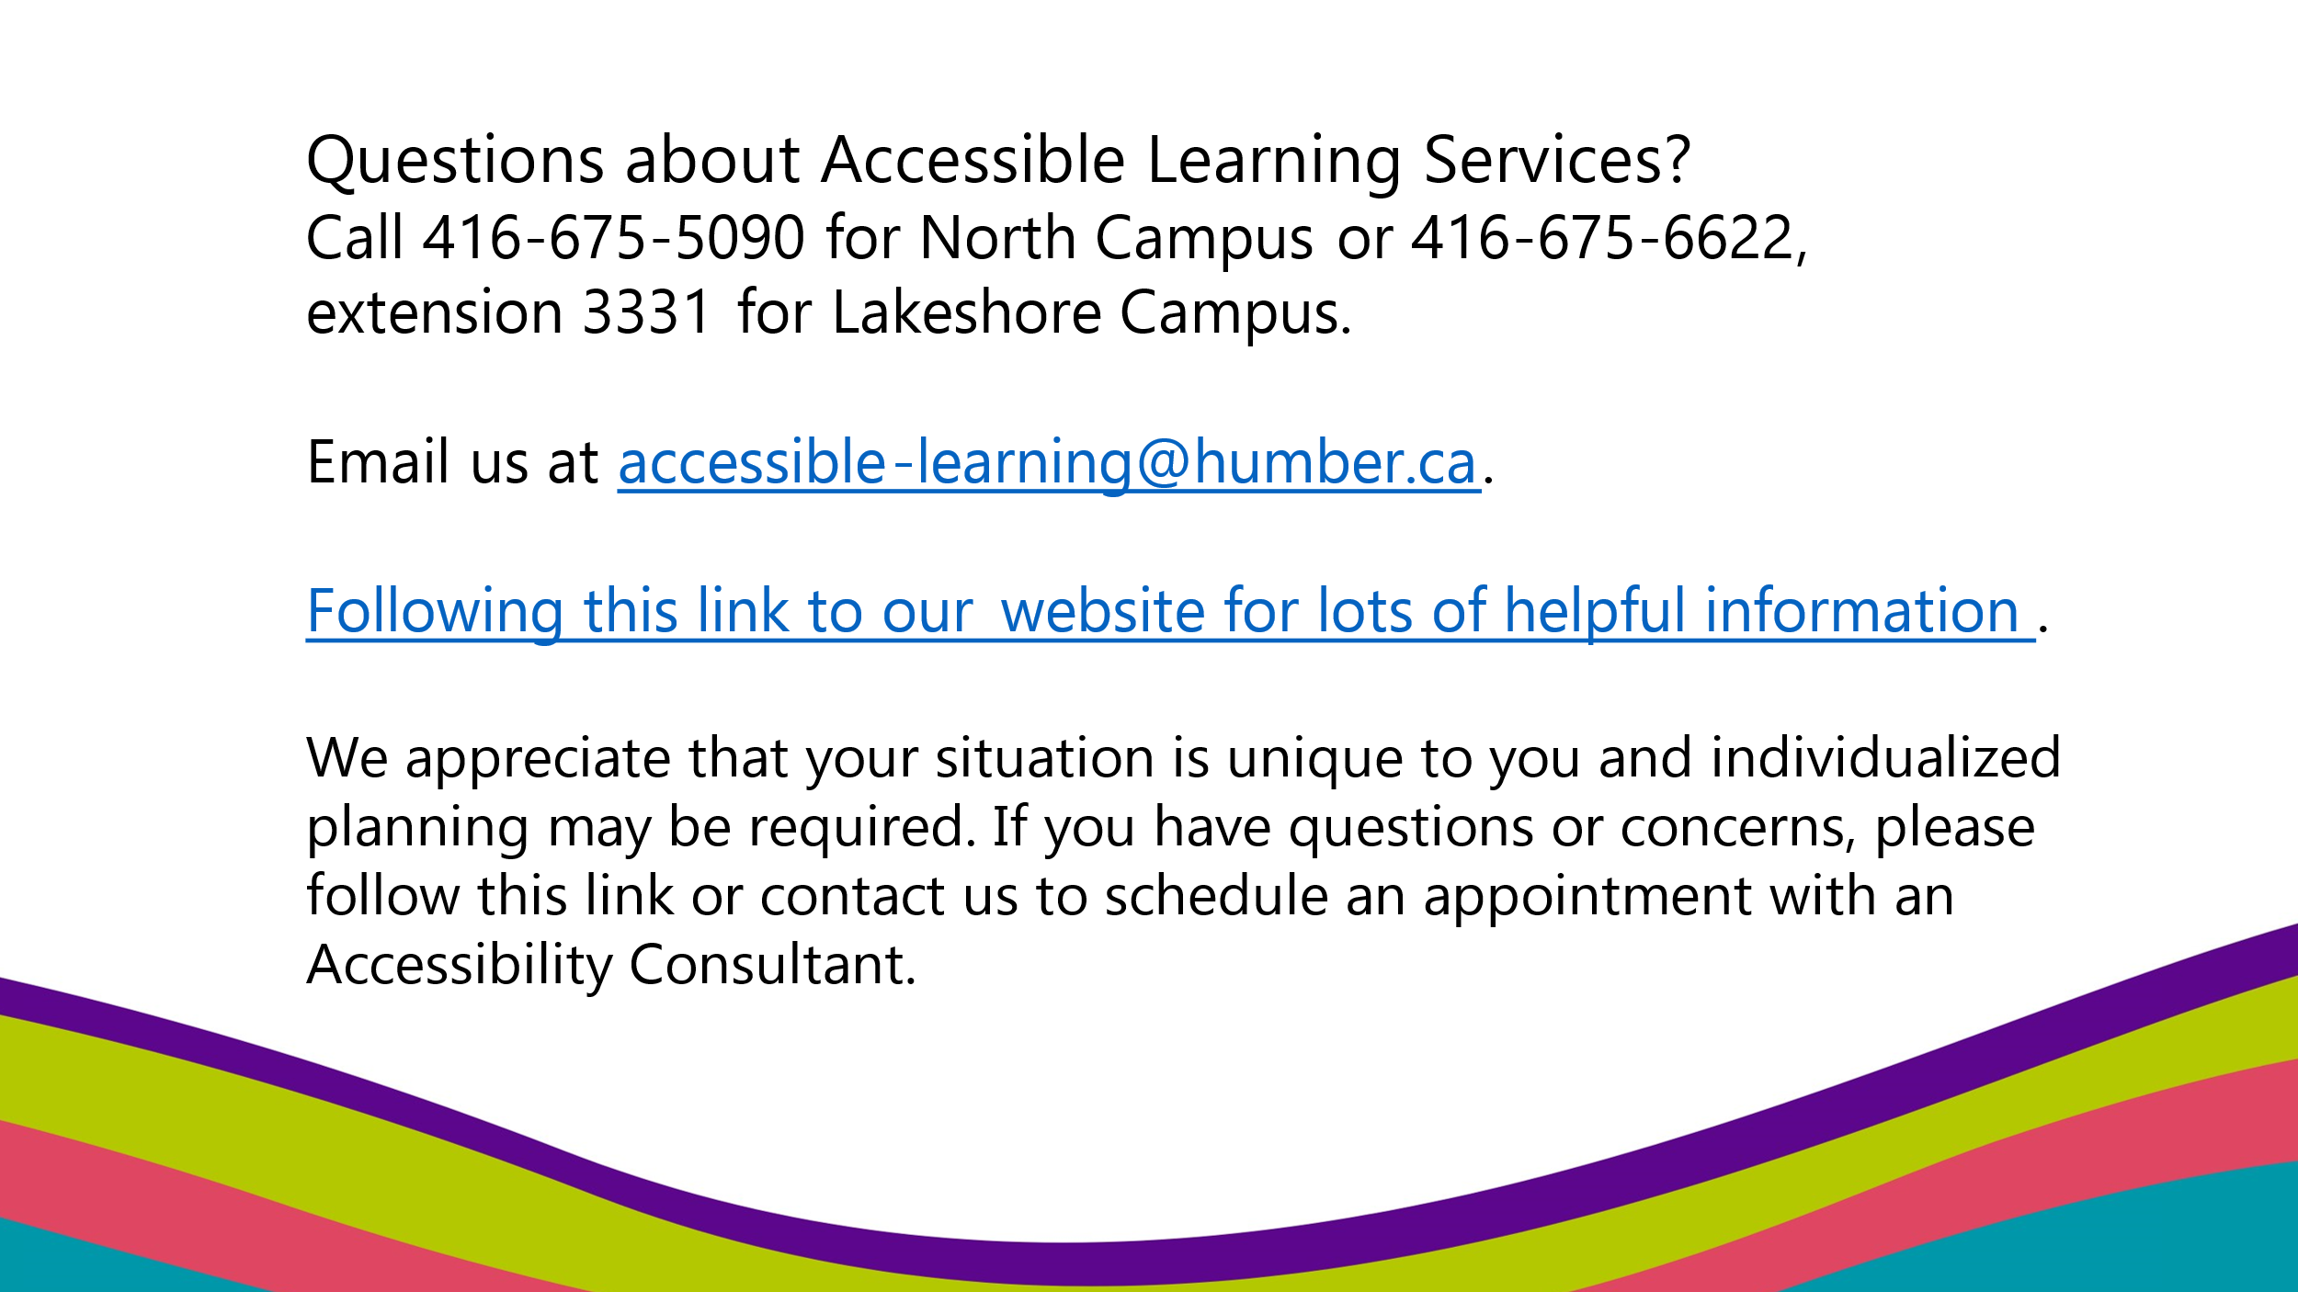

* Do you have questions about accessible learning services?
* Please color North Campus at (416) 675-5090 or Lakeshore Campus at (416) 675-6622, extension 3331 or email us at [accessible-learning@humber.ca](mailto:accessible-learning@humber.ca)
* You can also visit [Accessible Learning Services website](https://humber.ca/student-life/swac/accessible-learning) for lots of helpful information.
* We appreciate that your situation is unique to you, and individualized planning may be required.
* If you have questions or concerns, please contact us to schedule an appointment with an Accessibility Consultant.