# Student Learning Services

This document contains information regarding Student Learning Services based on a video produced on this content. Below you will find images of a PowerPoint presentation and all information contained in the images as a transcript below each slide.

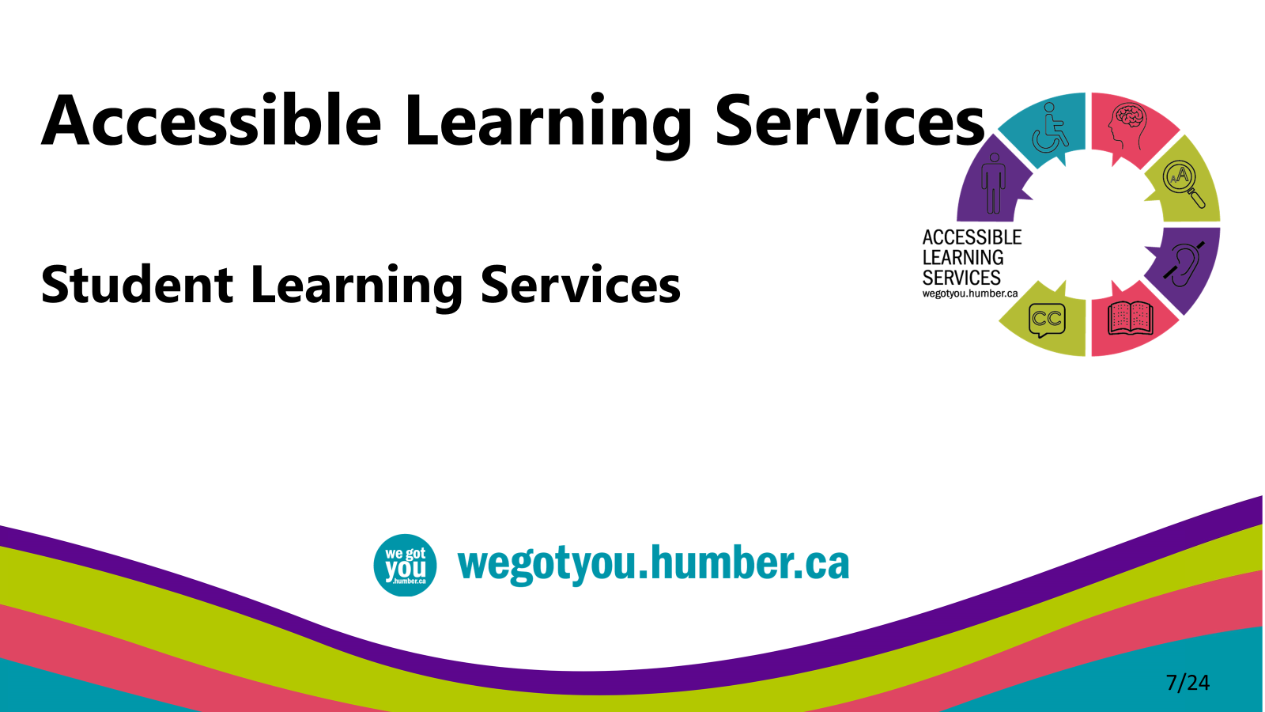

* This video is intended to introduce you to Student Learning Services and the support services they offer to help you achieve your academic goals.
* We have provided options for proceeding this content in the spirit of Universal Design for learning.

## Student Learning Services

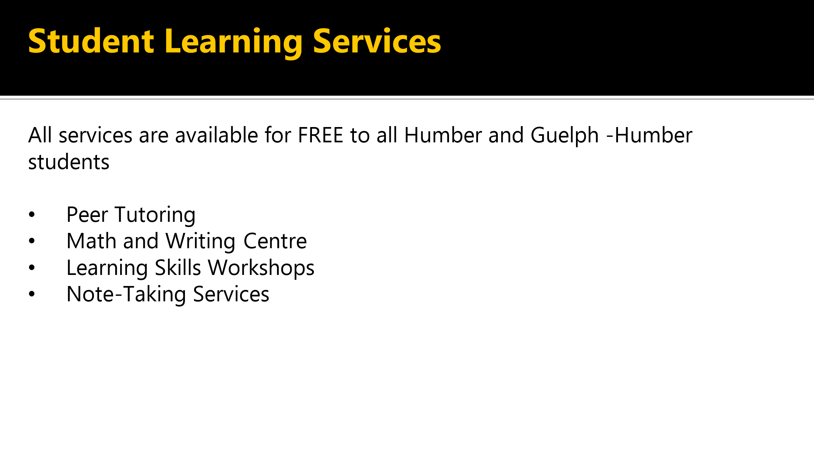

* All services are available for free to all Humber and Guelph Humber students including peer tutoring, math and writing centre learning skills workshops and note-taking services.

## Peer Tutoring

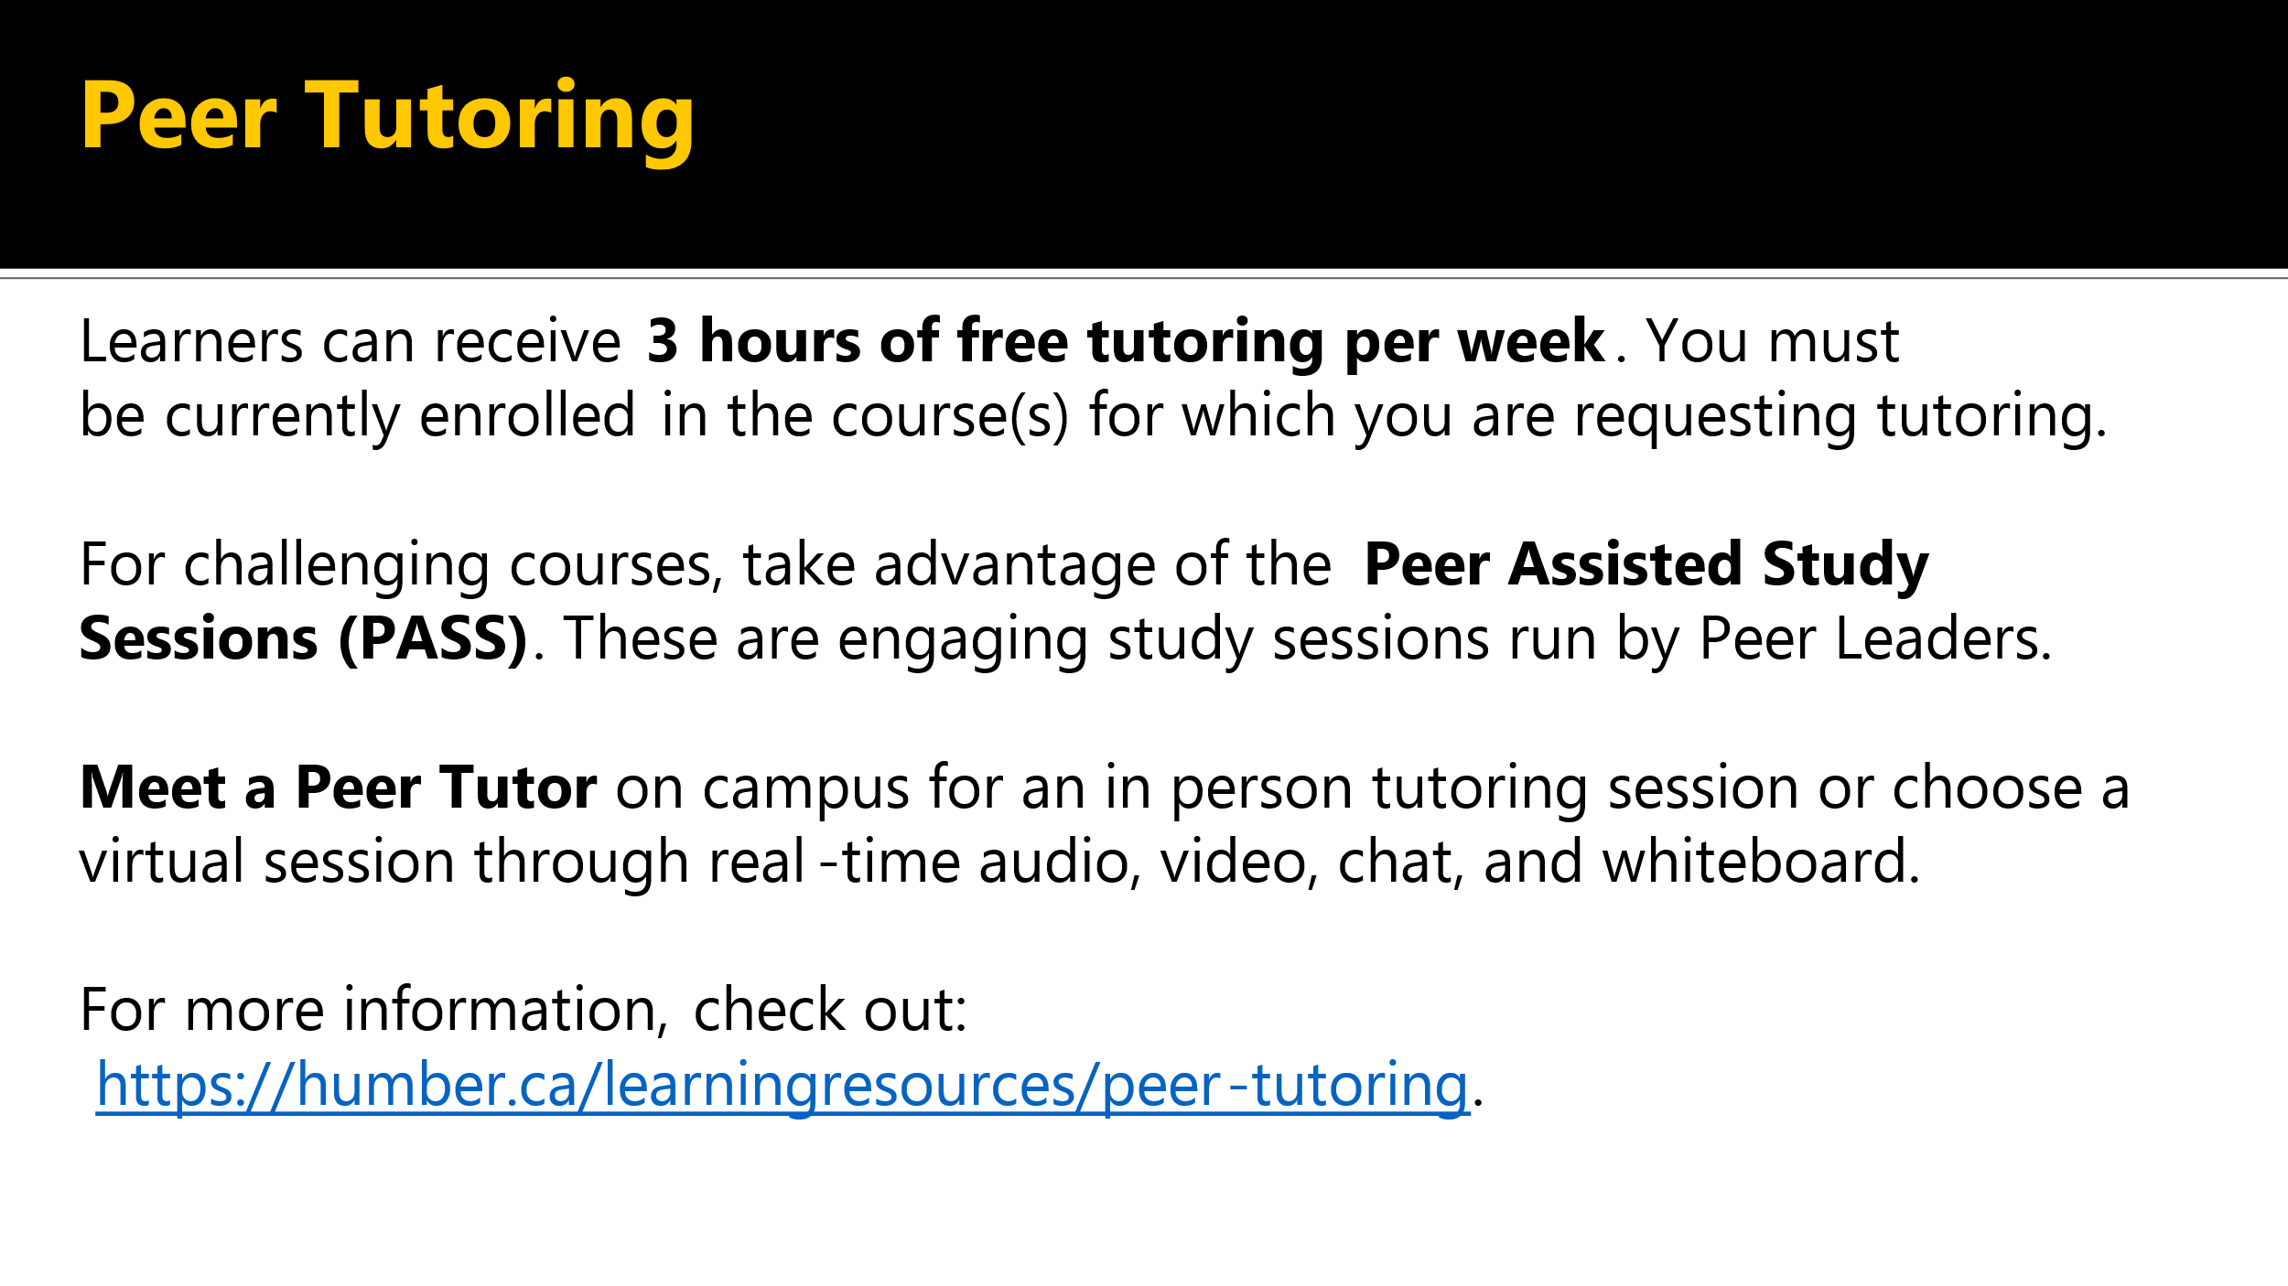

* Peer tutoring, learners can receive three hours of free tutoring per week.
* You must be currently enrolled in the course or courses for which you are requesting tutoring.
* For challenging courses, take advantage of the peer-assisted study sessions or PASS. These are engaging study sessions run by Peer Leaders.
* Meet a Peer Tutor on campus for an in-person tutoring session, or choose a virtual session through real time audio, video chat, and whiteboard.
* For more information, check out [Peer Tutoring website](http://humber.ca/learningresources/peer-tutoring).

## Math and Writing Centre

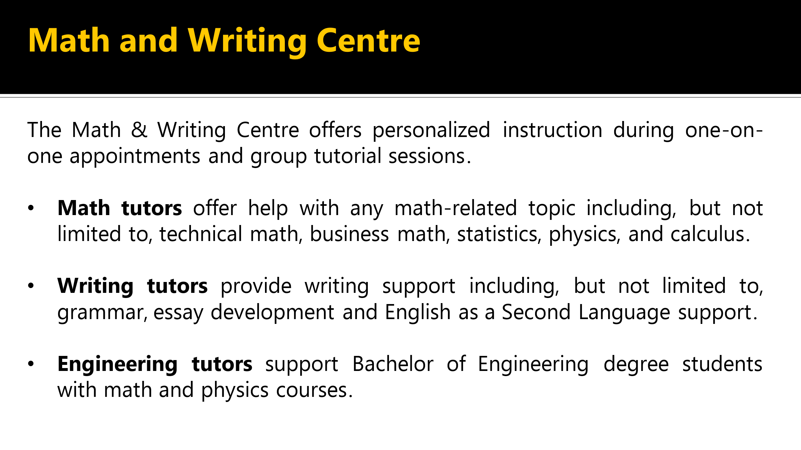

* Math and Writing Center. The Math and Writing Center provides support and tutoring to all learners.
* They offer personalized instructions during one-on-one appointments and group tutorial sessions.
* Math tutors offer help with any math related topic, including but not limited to technical math, business, math, statistics, physics, and calculus.
* Writing tutors provide writing support including but not limited to, grammar, essay development, research skills, business writing, English as a Second language support and citing sources.
* Engineering Tutors provide support to Bachelor of Engineering degree students with math and physics courses.

## Learning Skills Workshops (LSWs)

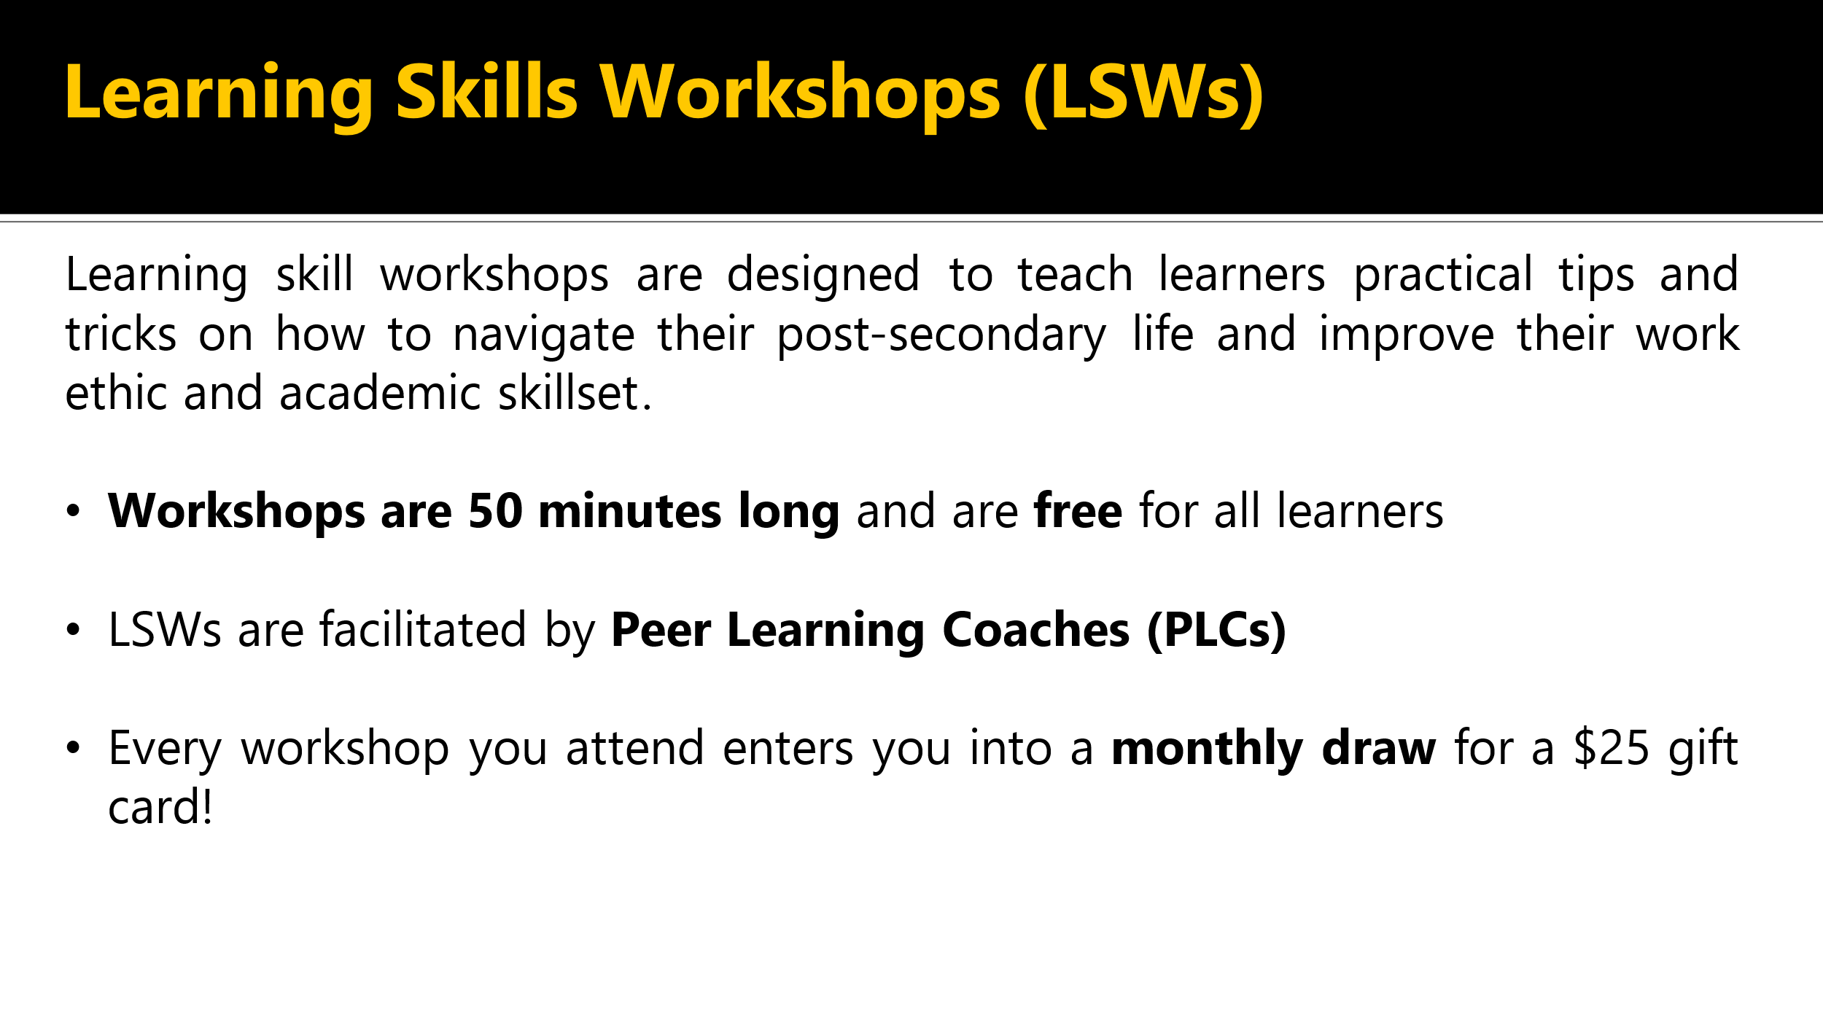

* Learning Skills Workshops or LSWs. Learning Skills Workshops are designed to teach learners practical tips and tricks on how to navigate their post-secondary life and improve their work ethic and academic skill set.
* Workshops are 15 minutes long and are free for all learners.
* LSWs studies are facilitated by Peer Learning Coaches or PLCs.
* Every workshop you attend enters you into a monthly draw for a $25 gift card.

## Workshops Topics

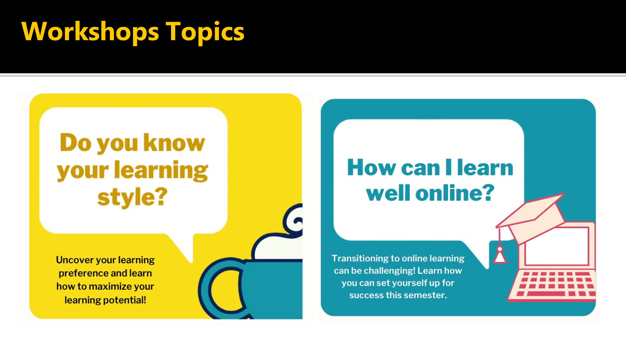

* Workshop topics include: Do you know your learning style? Uncover your learning preferences and learn how to maximize your learning potential.
* Another topic. How can I learn well online? Transitioning to online learning can be challenging.
* Learn how you can set yourself up for success this semester.

## Workshops Topics

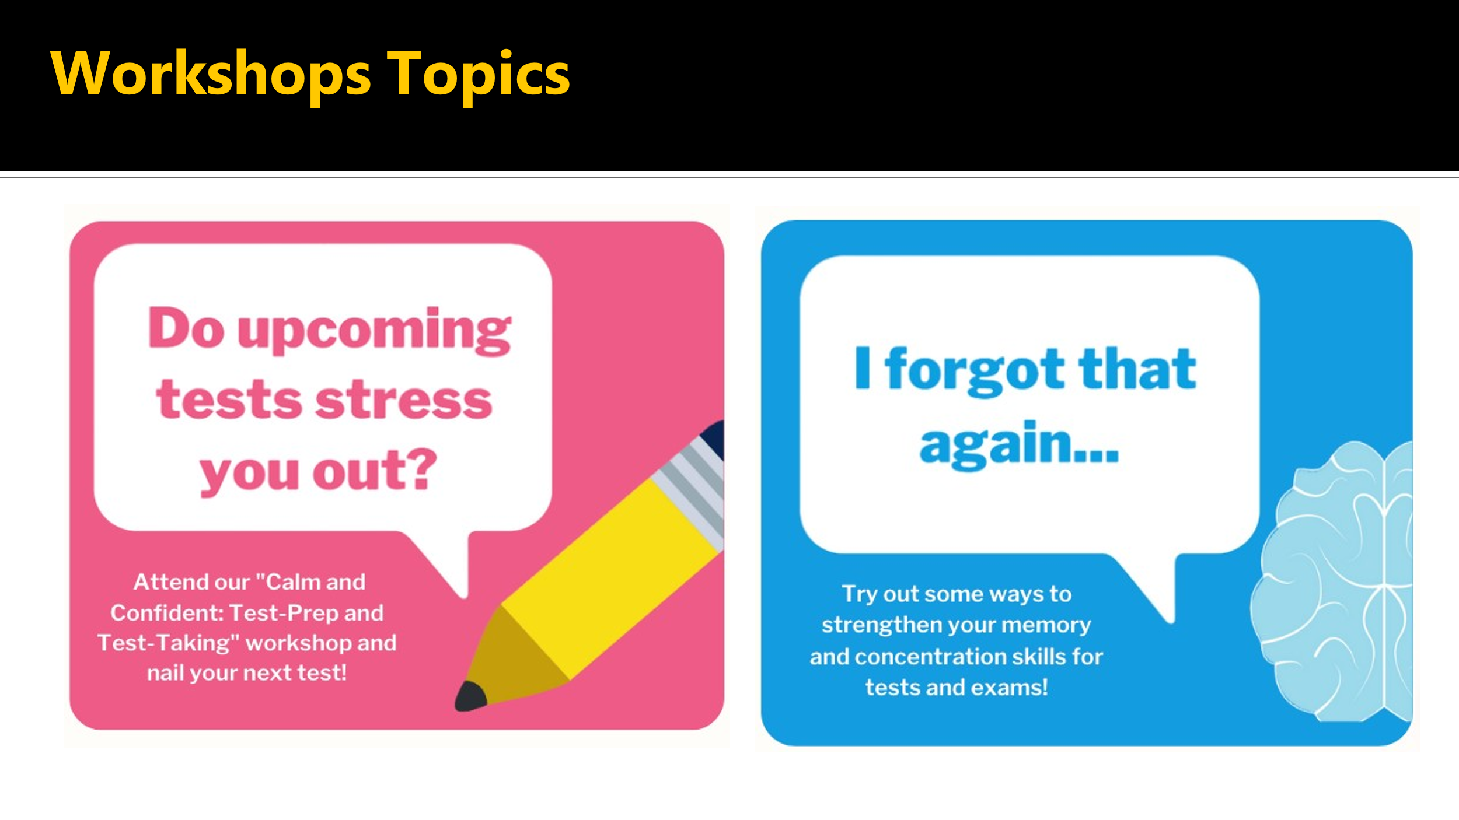

* Do upcoming tests stress you out? Attend our Calm and Confident Test Prep and Test Taking workshop and nail your next test.
* I forgot that again. Try out some ways to strengthen your memory and concentration skills for tests and exams.
* For more information, please follow [this link to the Learning Skills Workshop webpage](https://humber.ca/learningresources/learning-skills-workshops).

## Note-Taking Services

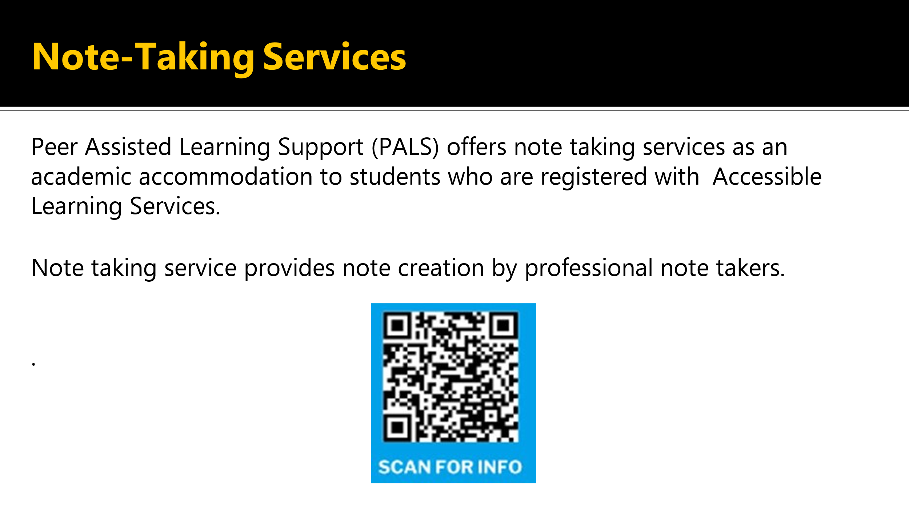

* Peer Assisted Learning Support or PALS offers note-taking services as academic accommodation to students registered with Accessible Learning Services.
* Note taking service provides note creation by professional note takers.
* You can use this QR code that's displayed on the screen to scan or follow [this link for note taking services](https://humber.ca/learningresources/note-taking-services).

## Steps to Note-Taking Services

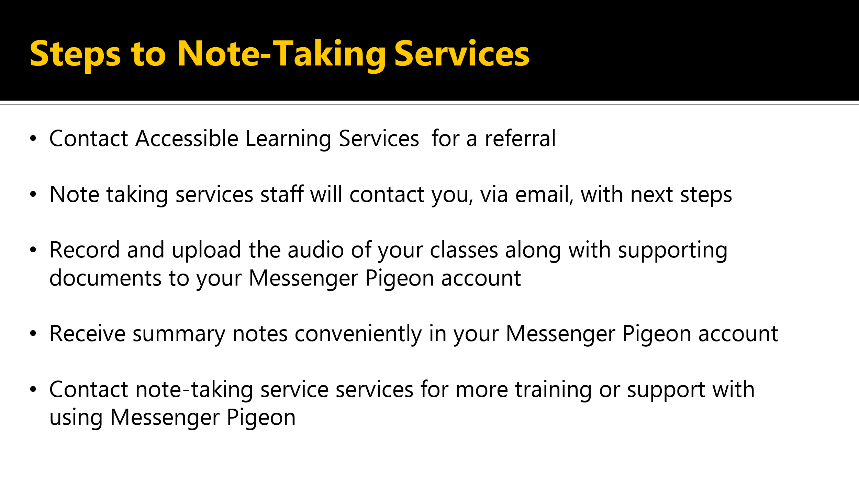

* Contact Accessible Learning Services for a referral.
* Note taking services staff will contact you via email with next steps.
* Record and upload the audio of your classes along with supporting documents to your Messenger Pigeon account.
* Receive summary notes conveniently in your Messenger Pigeon account.
* Contact note taking services for more training or support with using Messenger Pigeon.

## Connect With Student Learning Services

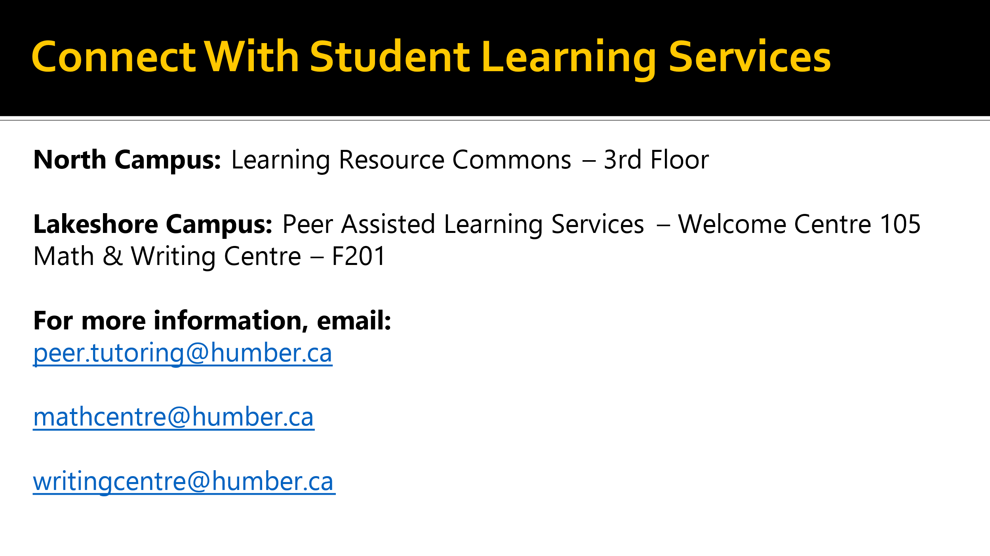

* You can connect to student learning services on North Campus in the Learning Resource Commons on the third floor.
* At Lake Shore Campus, Peer Assisted Learning Services is located in the Welcome Center, Room 105, and the Math and Writing Centre is located in F201.
* You can contact peering tutoring by email [peer.tutoring@humber.ca](mailto:peer.tutoring@humber.ca), the math centre at [mathcentre@humber.ca](mailto:mathcentre@humber.ca) and the writing centre at [writingcentre@humber.ca](mailto:writingcentre@humber.ca)

## Questions about Accessible Learning Services?

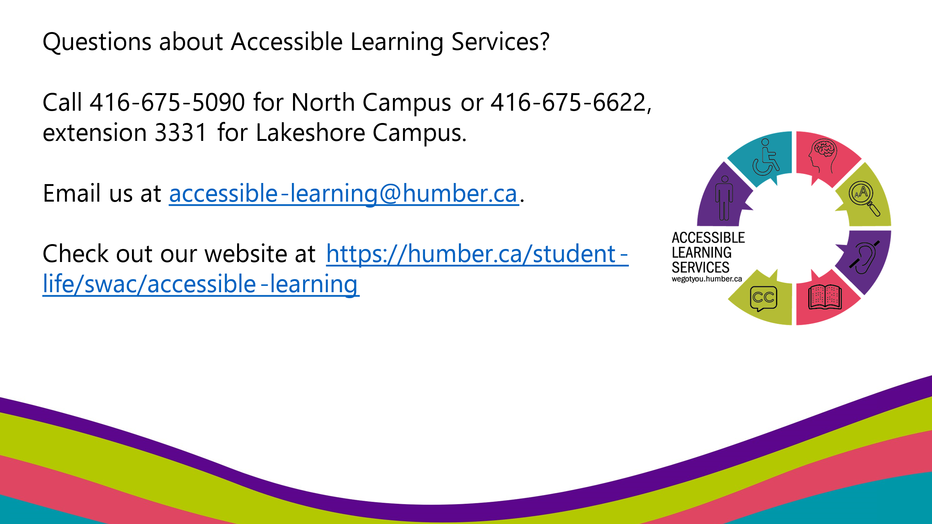

* Do you have additional questions about Accessible Learning Services?
* Call our North Campus at (416) 675-5090 or Lakeshore at (416) 675-6622, extension 3331 or email us at [accessible-learning@humber.ca](mailto:accessible-learning@humber.ca)
* You can also visit [Accessible Learning Services website](https://humber.ca/student-life/swac/accessible-learning) for lots of useful information.