# What is Accessible Learning Services

This document contains information about Accessible Learning Services based on a video produced on this content.  Below you will find images of a PowerPoint presentation and all information contained in the images as a transcript below each slide.

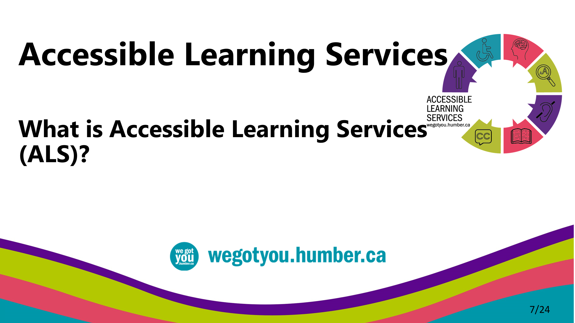

* The purpose of this presentation is to introduce you to Accessible Learning Services, or ALS.

## Student Wellness and Accessibility Centres

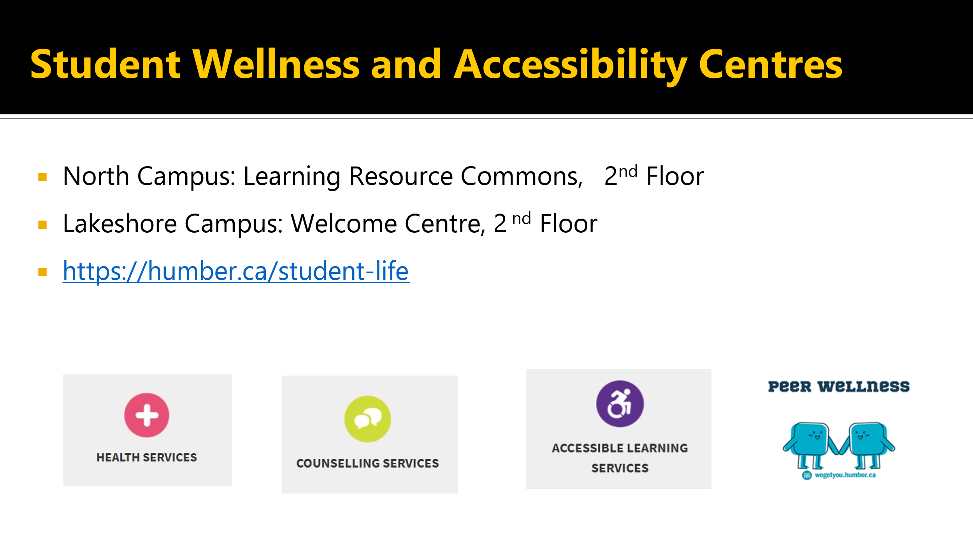

* ALS is located in the Student Wellness and Accessibility Centres at both North and Lakeshore campuses.
* At North Campus, we are located in the Learning Resource Commons, or LRC building on the second floor
* At Lakeshore Campus we are located in the Welcome Center, also on the second floor.
* Student Wellness and Accessibility Centres are comprised of health services, counselling services, accessible learning services, and peer wellness.
* Follow [this link to Student Wellness and Accessibility Centre.](https://humber.ca/student-life)

## Role of Accessible Learning Services

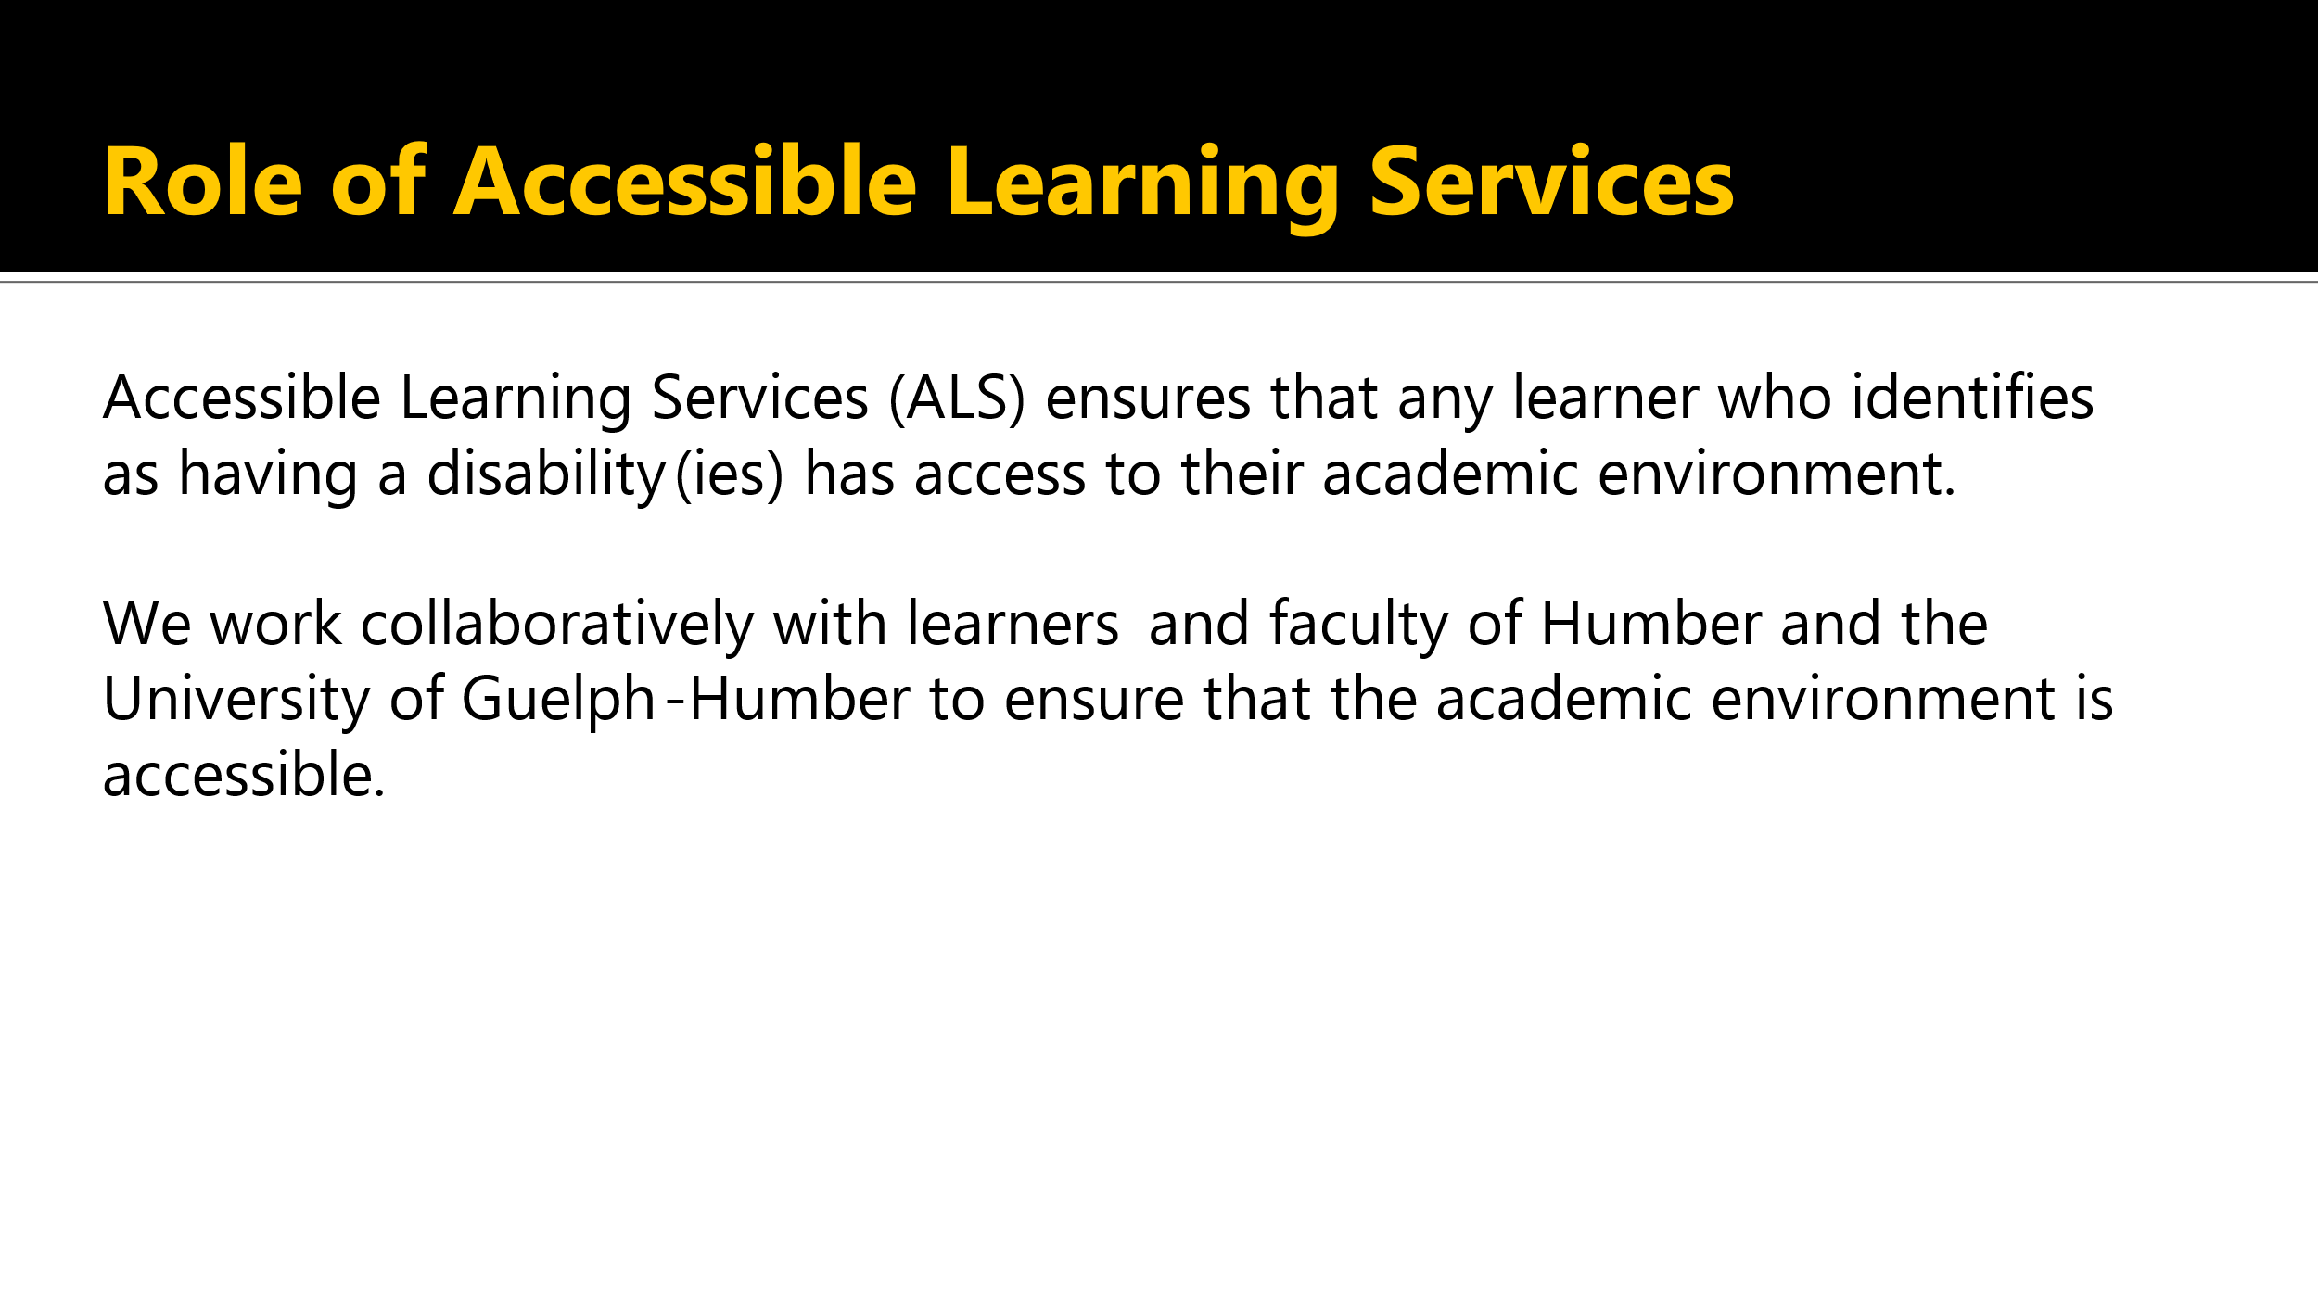

* The role of Accessible Learning Services, or ALS, is to ensure that any learner who identifies as having a disability or disabilities has access to their academic environment.
* We work collaboratively with learners and faculty of Humber College and the University of Guelph-Humber to ensure that the academic environment is accessible.

## Ways ALS Supports Learners

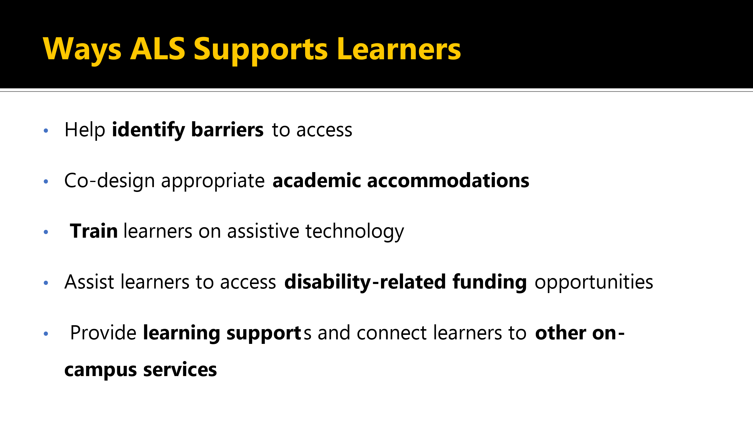

* ALS supports learners by helping to identify barriers to access co-designing appropriate academic accommodations, providing training to learners on assistive technology, and assisting learners to access disability related funding opportunities.
* Providing learning support and connecting learners to other on campus services.

## How Does Being Connected with ALS Shape the Learner Experience?

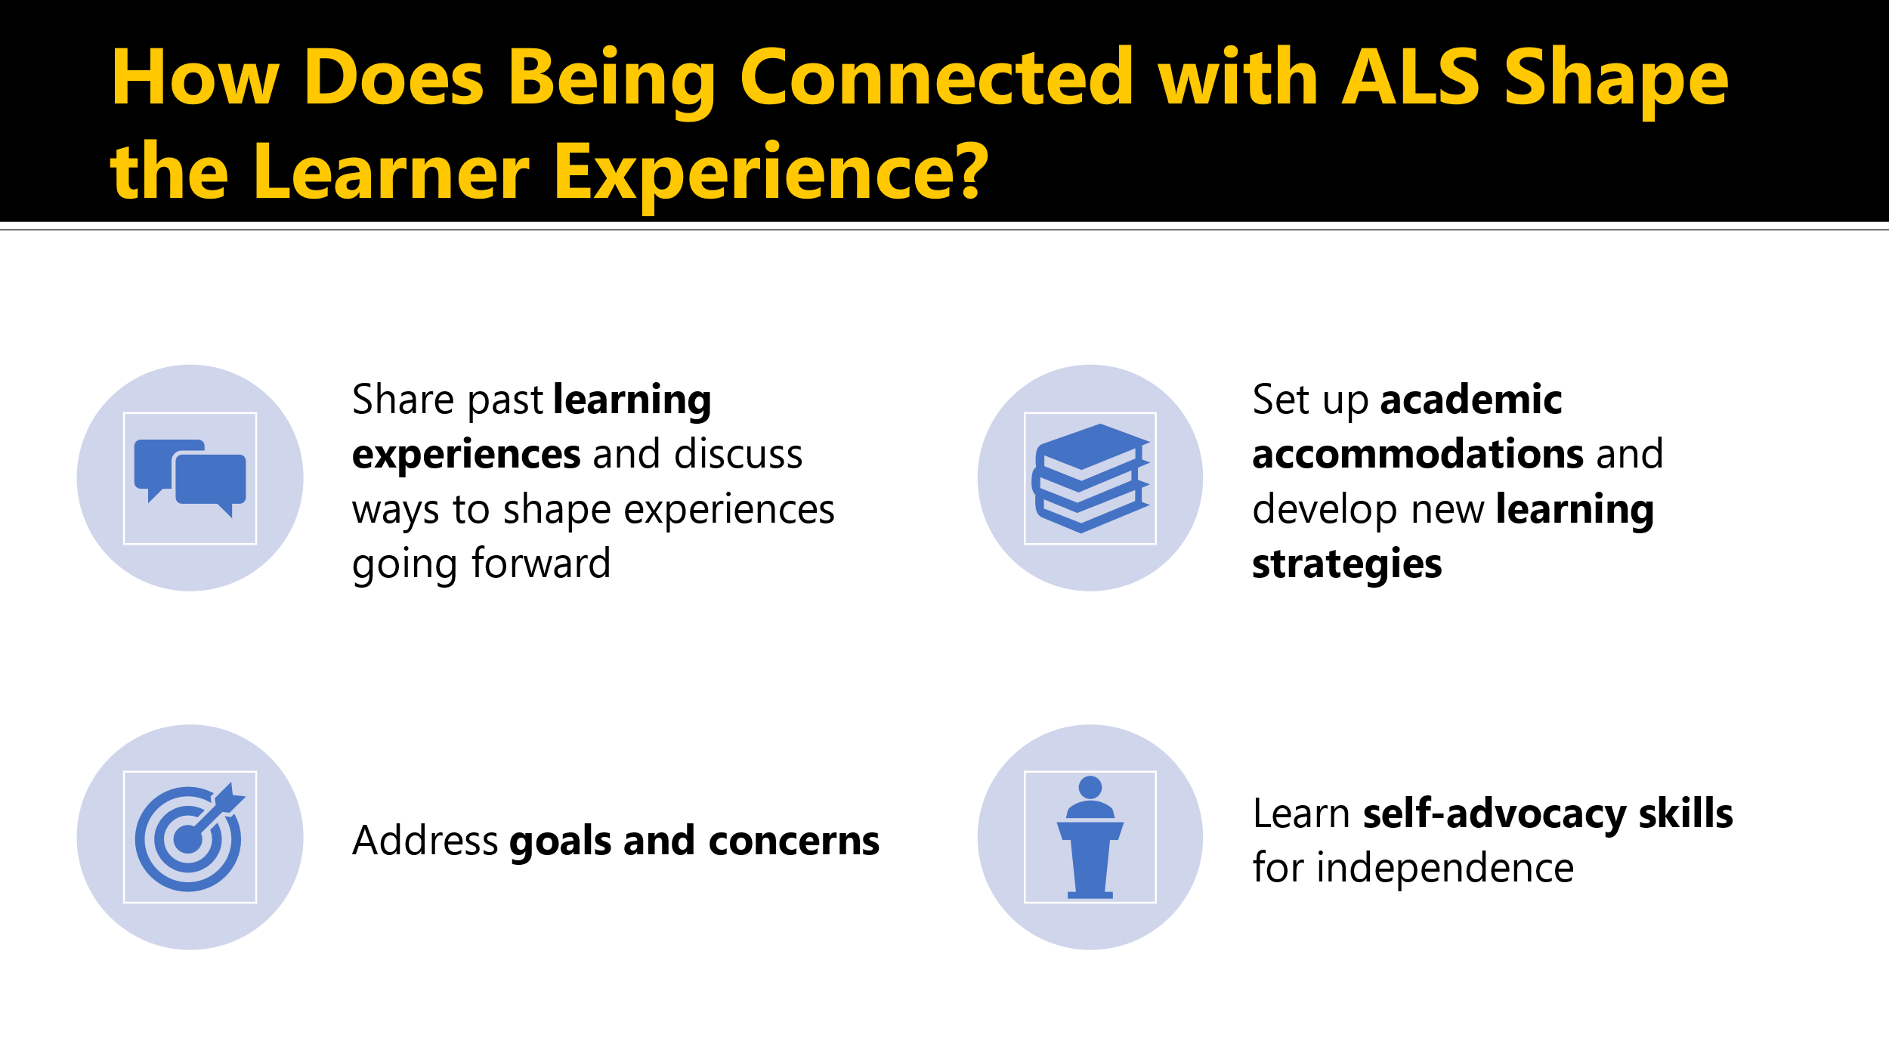

* Being connected with ALS shapes the learners experience by giving them the opportunity to share past learning experiences and discuss ways to shape experiences going forward, allowing learners to address their goals and concerns, setting up academic accommodations and developing new learning strategies, and supporting with learning self-advocacy skills for independence.

## Accessible Learning Services works to support:

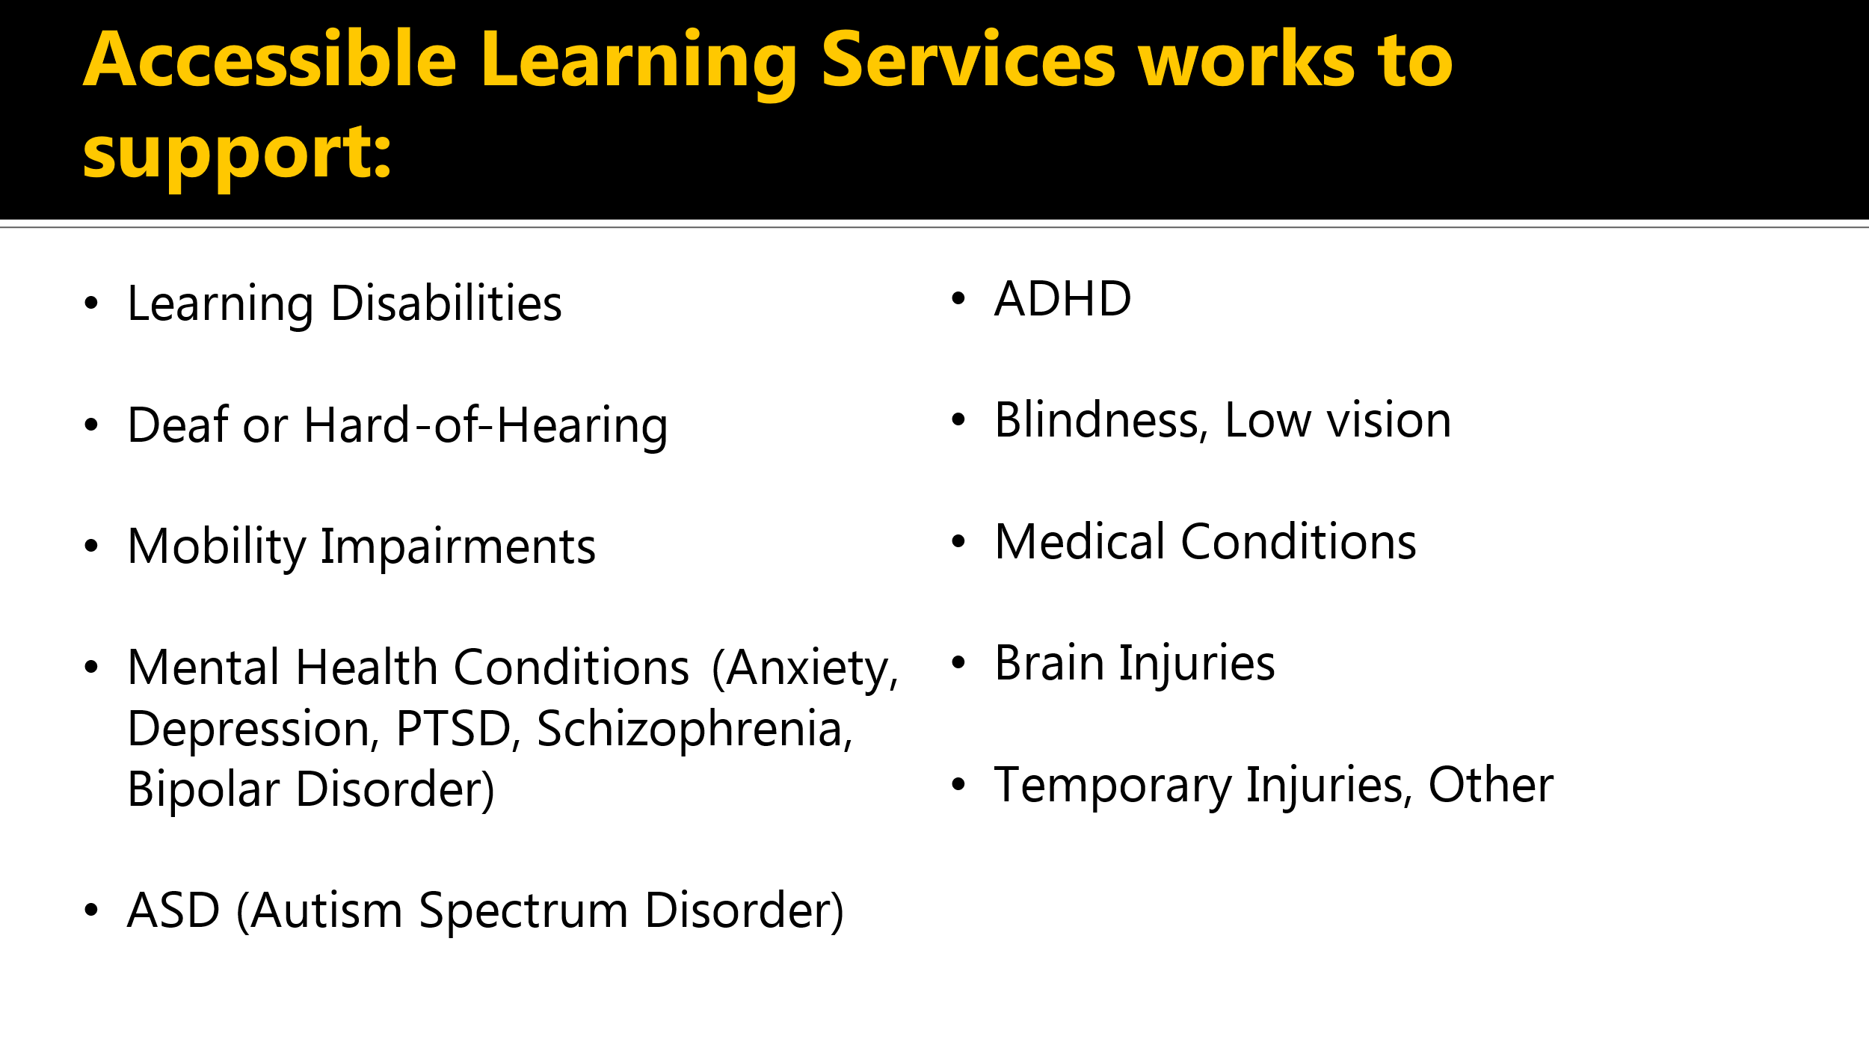

* Accessible Learning Services works to support individuals with learning disabilities, deaf or hard of hearing, mobility impairments, mental health conditions such as anxiety, depression, PTSD, schizophrenia, bipolar disorder, ASD or autism spectrum disorder, ADHD, blindness, low vision, medical conditions, brain injuries, temporary injuries, and others.

## Confidentiality and Informed Consent

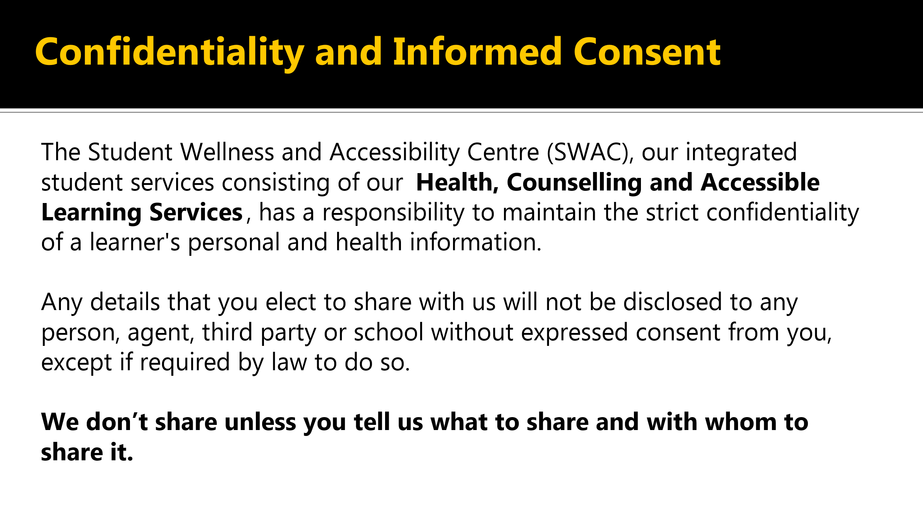

* The Student Wellness and Accessibility Centre, or SWAC, our Integrated Student Services, consisting of health, counselling and accessible learning services has a responsibility to maintain the strict confidentiality of the learner's personal and health information.
* Any details you want to share with us will not be disclosed to any person, agent, third party, or school without your consent, except if required by law.
* We don't share unless you tell us what to share and with whom to share it.

## Rights and Protections

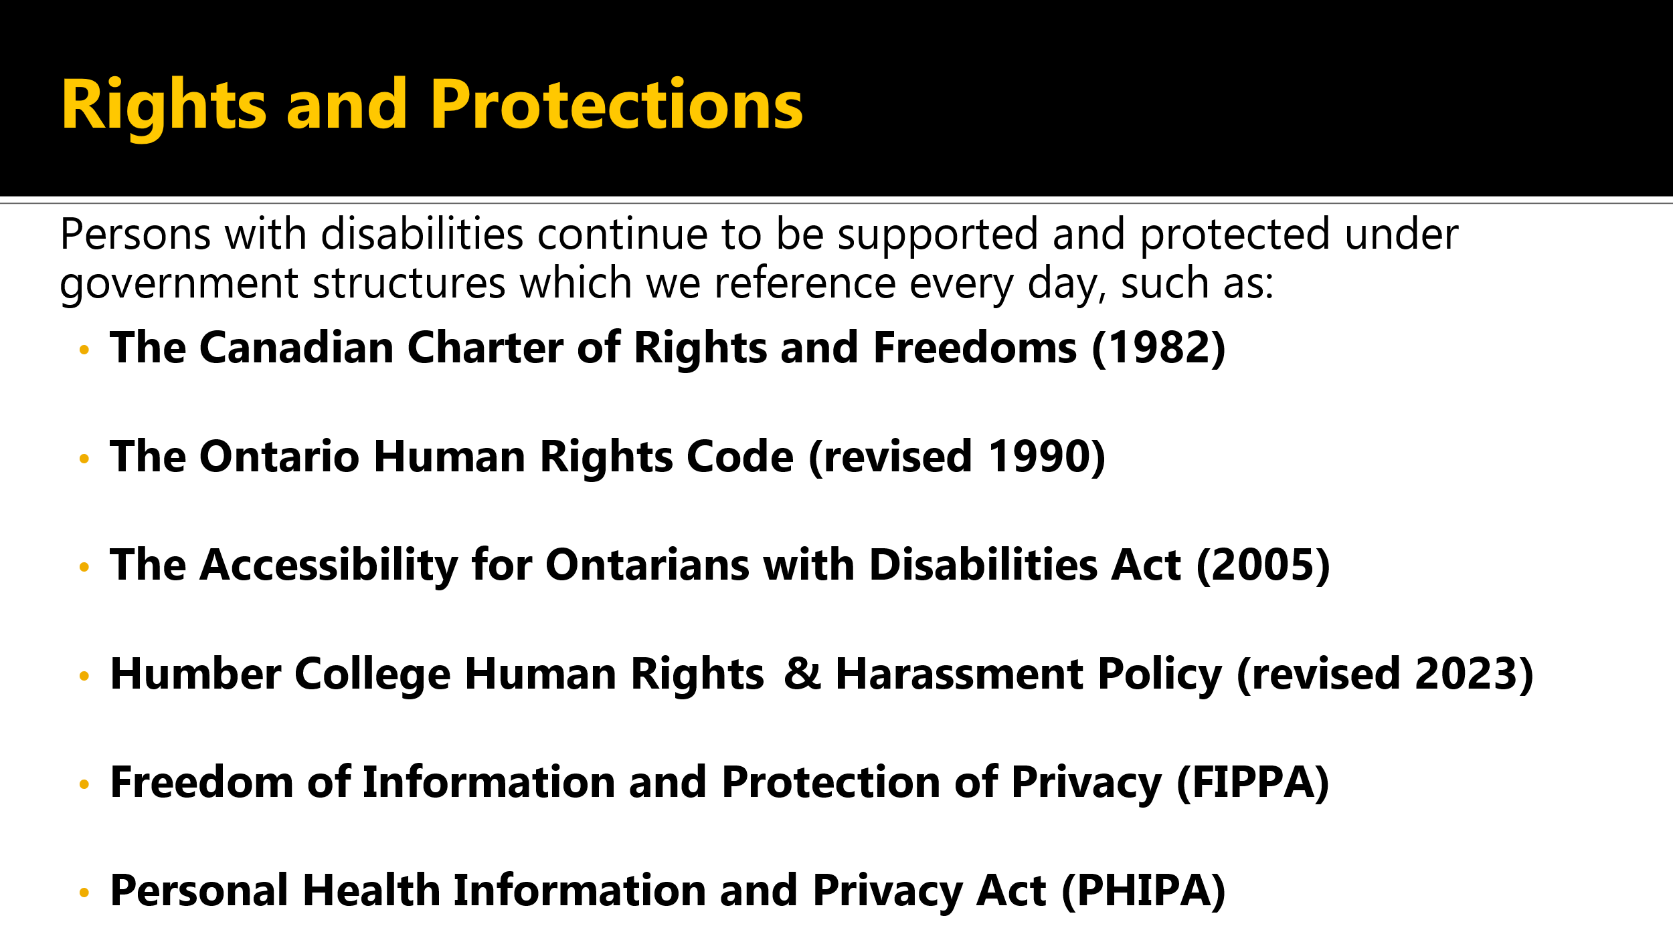

* Rights and Protections. Persons with disabilities continue to be supported and protected under government structures, which we reference every day, such as:
* [The Canadian Charter of Rights and Freedoms from 1982](https://www.justice.gc.ca/eng/csj-sjc/rfc-dlc/ccrf-ccdl/).
* [The Ontario Human Rights Code revised in 1990](https://www.ola.org/en/office-assembly/library-research/research-papers/ontarios-human-rights-code).
* [The Accessibility for Ontarians with Disabilities Act from 2005](https://www.aoda.ca/the-act/).
* [Humber College Human Rights and Harassment Policy, revised 2023](https://humber.ca/legal-and-risk-management/policies/human-resources/human-rights-and-harassment-policy.html).
* [Freedom of Information and Protection of Privacy](https://www.ontario.ca/laws/statute/90f31) or FIPPA and [Personal Health Information and Privacy Act](https://www.ontario.ca/laws/statute/04p03) or PHIPA.

## Questions about Accessible Learning Services?

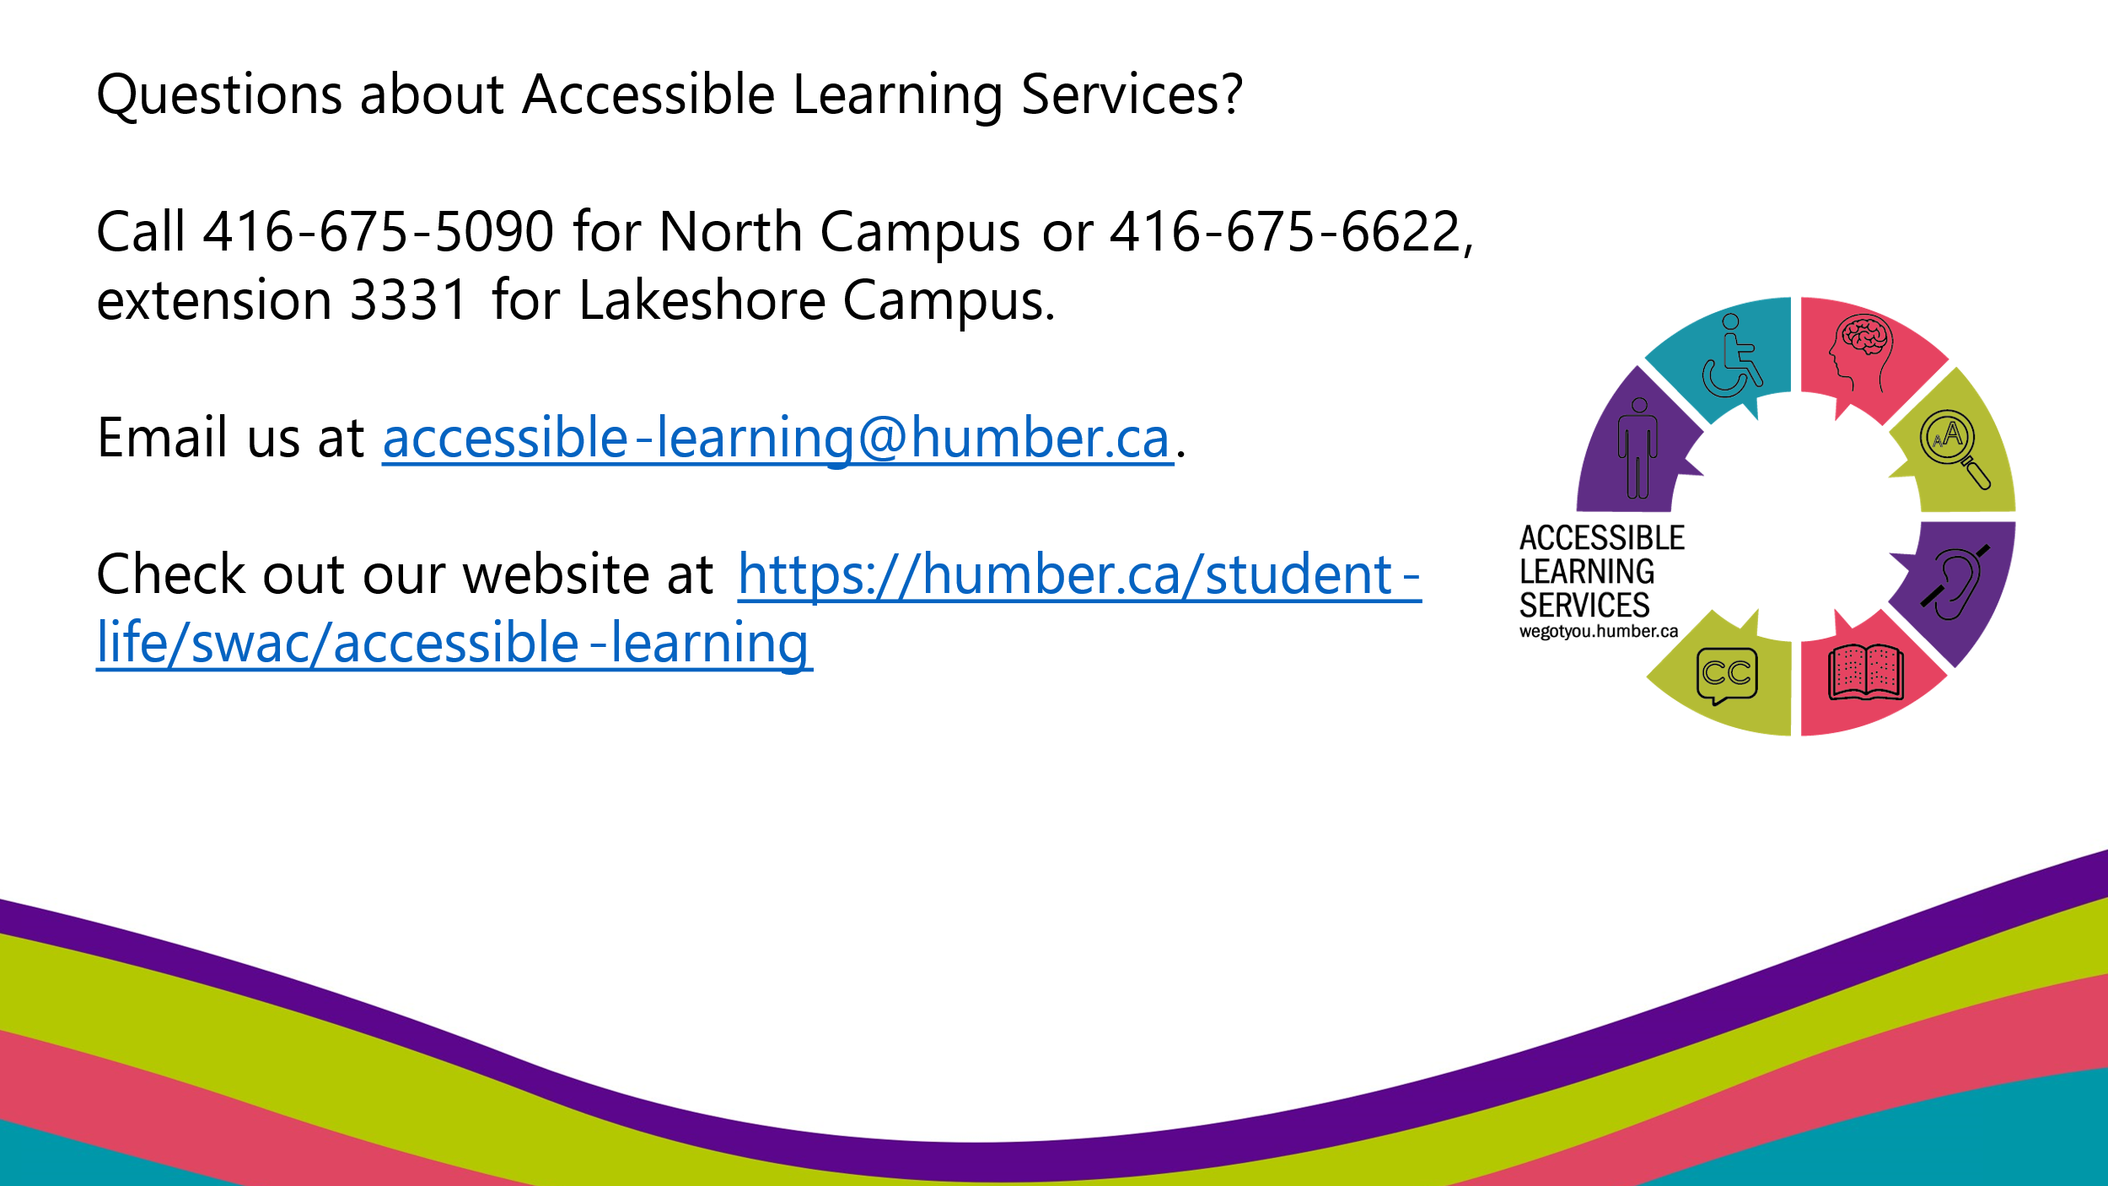

* Do you have questions about Accessible Learning Services?
* We can be reached by phone at our North Campus at (416) 675-5090 and Lakeshore at (416) 675-6622, extension 3331.
* You can also email us at [accessible-learning@humber.ca](mailto:accessible-learning@humber.ca)
* Check out our [Accessible Learning Services website](humber.ca/student-life/swac/acccessible-learning)